IBM Application Modernization Accelerator (AMA) Lab

Lab guide

<Level 3 client-facing course codes>



**Document edition: June 2025**

**LEGAL NOTICES**

This information was developed for products and services offered in the USA. IBM may not offer the products, services, or features discussed in this document in other countries. Consult your local IBM representative for information on the products and services currently available in your area. Any reference to an IBM product, program, or service is not intended to state or imply that only that IBM product, program, or service may be used. Any functionally equivalent product, program, or service that does not infringe any IBM intellectual property right may be used instead. However, it is the user's responsibility to evaluate and verify the operation of any non-IBM product, program, or service. IBM may have patents or pending patent applications covering subject matter described in this document. The furnishing of this document does not grant you any license to these patents. You can send license inquiries, in writing, to:

IBM Director of Licensing IBM Corporation  
North Castle Drive, MD-NC119 Armonk, NY 10504-1785  
United States of America

The following paragraph does not apply to the United Kingdom or any other country where such provisions are inconsistent with local law: INTERNATIONAL BUSINESS MACHINES CORPORATION PROVIDES THIS PUBLICATION “AS IS” WITHOUT WARRANTY OF ANY KIND, EITHER EXPRESS OR IMPLIED, INCLUDING, BUT NOT LIMITED TO, THE IMPLIED WARRANTIES OF NON-INFRINGEMENT, MERCHANTABILITY OR FITNESS FOR A PARTICULAR PURPOSE. Some states do not allow disclaimer of express or implied warranties in certain transactions; therefore, this statement may not apply to you. This information could include technical inaccuracies or typographical errors. Changes are periodically made to the information herein; these changes will be incorporated in new editions of the publication. IBM may make improvements and/or changes in the product(s) and/or the program(s) described in this publication at any time without notice. Any references in this information to non-IBM websites are provided for convenience only and do not in any manner serve as an endorsement of those websites. The materials at those websites are not part of the materials for this IBM product and use of those websites is at your own risk. IBM may use or distribute any of the information you supply in any way it believes appropriate without incurring any obligation to you. Information concerning non-IBM products was obtained from the suppliers of those products, their published announcements or other publicly available sources. IBM has not tested those products and cannot confirm the accuracy of performance, compatibility or any other claims related to non-IBM products. Questions on the capabilities of non-IBM products should be addressed to the suppliers of those products.

This information contains examples of data and reports used in daily business operations. To illustrate them as completely as possible, the examples include the names of individuals, companies, brands, and products. All names and references for organizations and other business institutions used in this deliverable’s scenarios are fictional. Any match with real organizations or institutions is coincidental. All names and associated information for people in this deliverable’s scenarios are fictional. Any match with a real person is coincidental.

TRADEMARKS

IBM, the IBM logo, and [ibm.com](http://ibm.com/) are trademarks or registered trademarks of International Business Machines Corp., registered in many jurisdictions worldwide. Other product and service names might be trademarks of IBM or other companies. A current list of IBM trademarks is available on the web at “Copyright and trademark information” at <https://www.ibm.com/legal/copyright-trademark>.

© Copyright International Business Machines Corporation 2025. This document may not be reproduced in whole or in part without the prior written permission of IBM.

Table of Contents

Introduction 1

About this lab 3

Steps for the lab tasks 4

# Introduction

Application Modernization Accelerator is a modernization tool designed to scan and discover your entire Java application estate. The applications are scanned in place to allow for the collection of their configuration so that a detailed picture of the connections between applications, database and queues can be discovered.

Analysis is provided to identify the challenges in going to a list of different runtime destinations and common code across the estate is identified to ensure the work of modernization is only done once, and not multiple times. Guidance is provided on how to build modernization momentum by concentrating on the applications that share common code, so code changes help to modernize as many applications as possible as quickly as possible.

The analysis and configuration collected during the scan is then used to generated migration artifacts that are customized for each application to accelerate the modernization of the application to the desired runtime destination.

The estate wide view of all stages of the process, from scanning, to analysis to modernization implementation allows for accurate planning, risk assessment and evaluation of the return-on-investment for each potential destination.

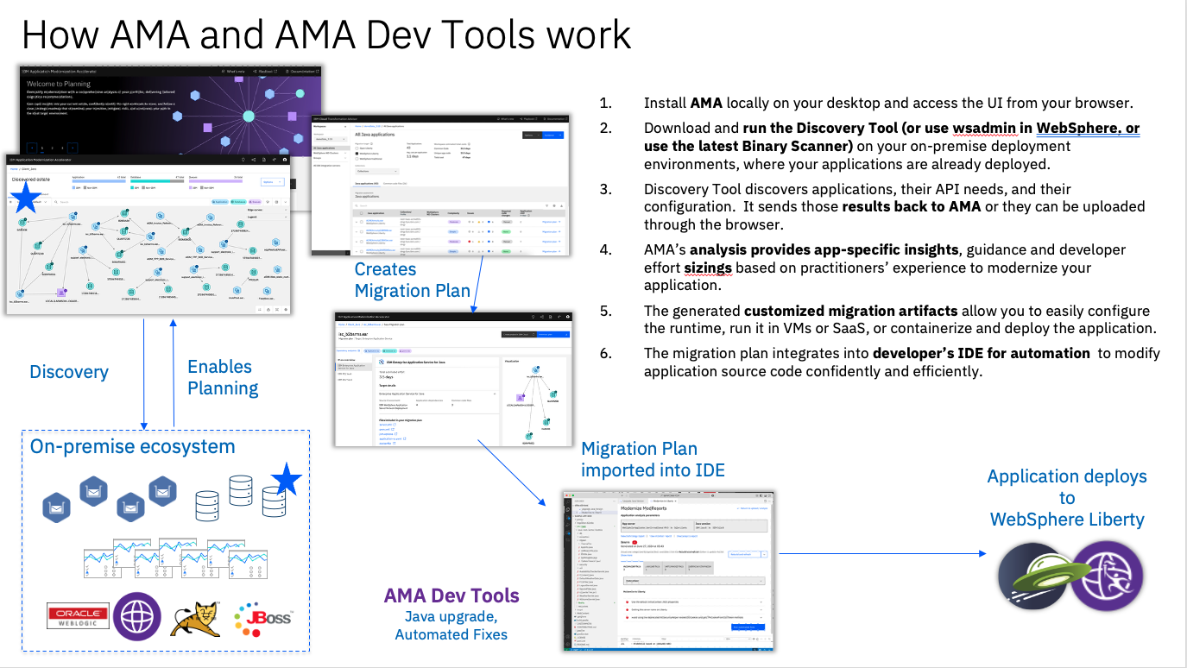

Application Modernization Accelerator developer tools are designed to run on your application source code and modernize both the Java runtime and the Java version

Java runtime modernization allows you to analyse your legacy enterprise Java application and modernize it to use a more lightweight, flexible, and efficient runtime. Receive a prescriptive plan that describes the changes that are needed to modernize your application with a detailed assessment of complexity and required development effort. Use automation to quickly implement code and configuration changes.

Java version modernization allows you to identify changes required to upgrade Java code and automatically update the relevant application code. Receive a prescriptive plan that describes the changes that are needed to upgrade your application with a detailed assessment of complexity and required development effort. Use automation to quickly implement code changes.

# About this lab

The main objective of this hands-on lab is to present an end-to-end overview of the capabilities of IBM Application Modernization Accelerator (AMA) and to explicitly show how the AMA developer tools can quickly and easily modernize Java applications.

Modernization is a complex area with many conflicting requirements. In essence the goal is always to modernize as much as possible as quickly as possible, but in practice modernization is “One size fits none.” There is rarely any return on investment to modernize all applications to the very latest technologies and architectures. AMA is designed to allow you to develop a strategy that best suits your business needs and then to accelerate its implementation.

AMA is designed to accelerate the modernization of your whole Java estate. In this lab you take on the role of the modernization architect who has been tasked with modernizing **InstantPayments**, an aging application infrastructure. While the whole estate needs to be modernized there is one critical business application that has been identified as needing to be modernized first. The business application is **WhereAmI** (version 2.0.0), which is a Java 8 application running on a traditional WebSphere Application Server (tWAS). Your objective is to modernize this application and move it to a modern runtime environment, IBM Modernized Runtime Extension for Java (MoRE). With MoRE you can

* Run modern applications without losing the stability, availability and security of the underlying operational infrastructure of tWAS
* Realize faster time to value with modernization and migration tools to support application transitions and improvements for current estate
* Improve consistency, efficiency, and collaboration while accelerating new app development between Operations teams and developers

You are going to use AMA to evaluate this application, to modify its code automatically and to prepare the migration package for moving from tWAS to MoRE.

In this lab, you are going to perform the following tasks:

1. Review the **WhereAmI** application deployed in the tWAS environment.
2. Install AMA local version.
3. Get familiar with AMA functions and capabilities.
4. Use AMA to analyse the **WhereAmI** application for the targeted MoRE environment, to create the migration bundle.
5. Use AMA Dev Tools to modify the code and make suggested changes.

# Steps for the lab tasks

1. Review the **WhereAmI** application in the tWAS environment.

The **WhereAmI** (version 2.0.0) application has been deployed to the tWAS environment, you are going to use the following steps to review it and get familiar with the tWAS environment.

* 1. Click the **terminal** **icon (A)** to open a **terminal** window.

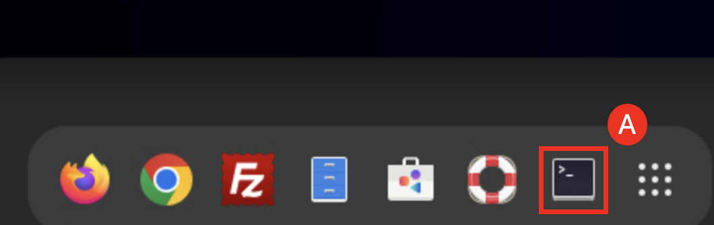

* 1. Start the WebSphere Deployment Manager, WebSphere ND Node Agents and IBM HTTP Server (IHS) by issuing the commands below:

cd /home/techzone/demos/ManagedLiberty-MoRE/tx-more-lab/scripts

./start-was-servers.sh



The WAS ND Manager, WAS Node Agents and IHS server are started.

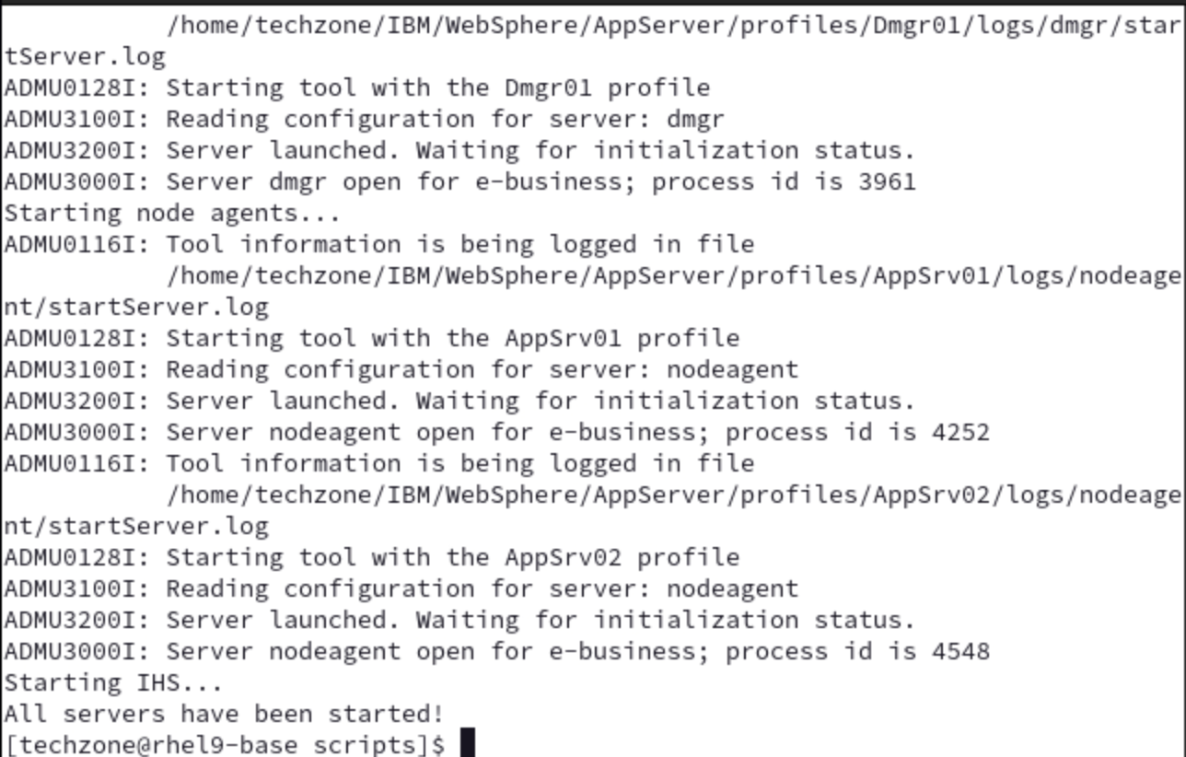

* 1. Access the WebSphere Integrated Solution Console (WAS Admin Console). Open a web browser window by clicking **Activities (A)** and clicking the **Firefox icon (B)**.

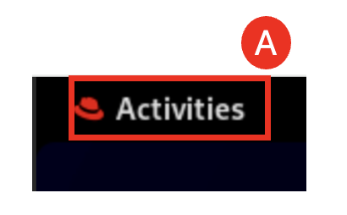

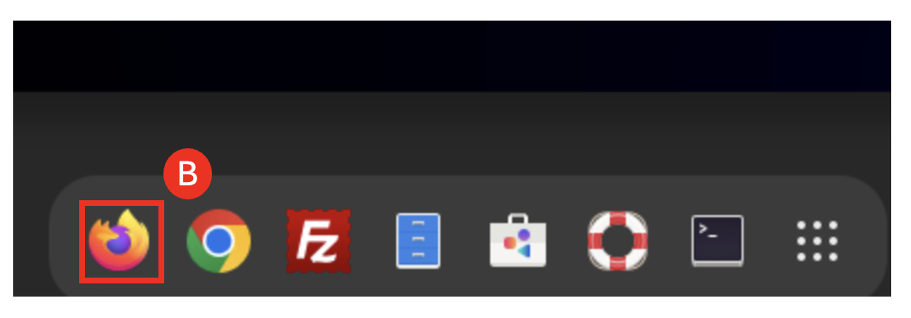

* 1. In the Firefox window, navigate to the WebSphere Integrated Solutions Console (WAS Admin Console) with URL: **https://localhost:9043/ibm/console (A)**

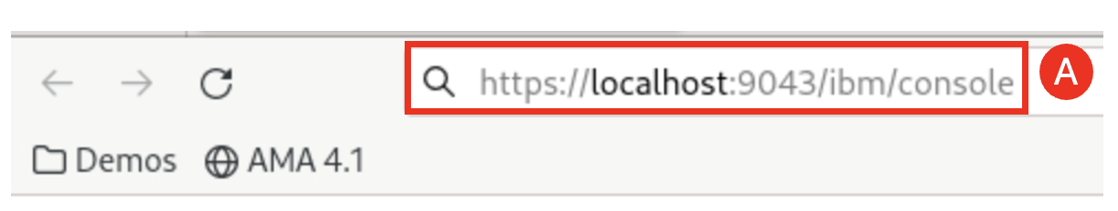

Note: If you see the message “Warning: Potential Security Risk Ahead..”, click **Advanced…** then click **Accept the Risk and Continue**.

* 1. Accept the default user ID and Password and click **Log in (A)**.

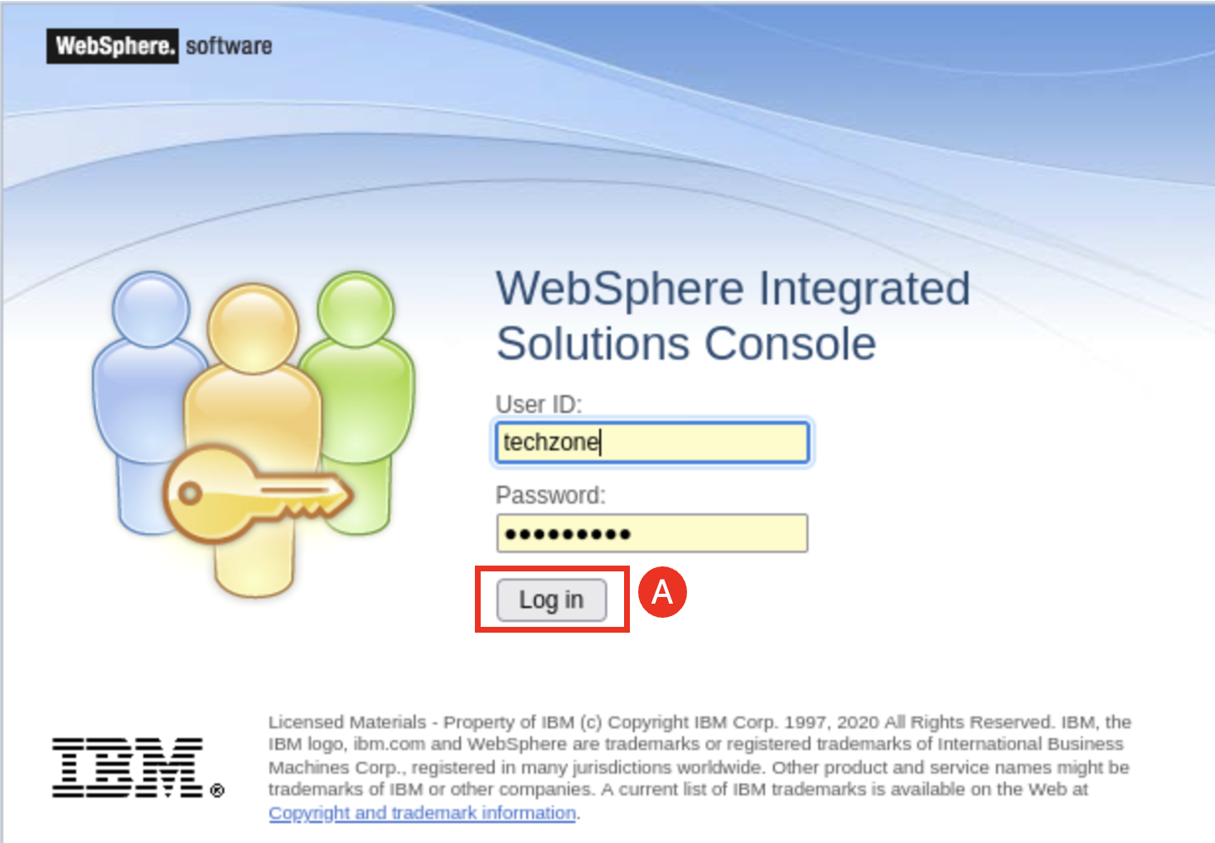

Note: the log in credentials are User ID: **techzone** Password: **IBMDem0s!**

* 1. If you see the following screen, select the **Long out option (A)** and click **OK (B)**.

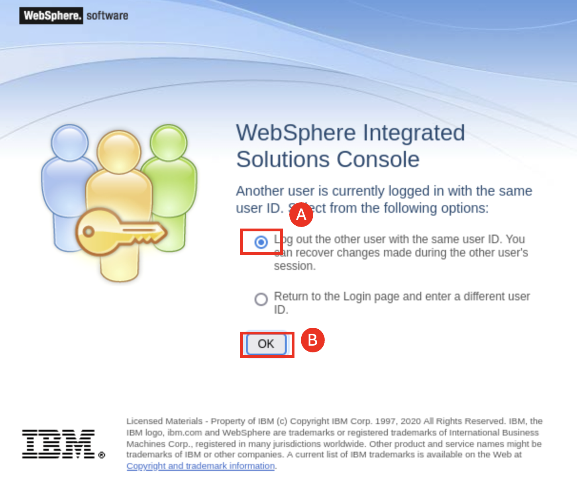

* 1. Start the tWAS cluster named **tWASCluster1** by selecting **Servers (A)** -> **Clusters (B)** -> **WebSphere application server clusters (C)**, checking the **box next the tWASCluster1 (D)** and clicking **Start (E)**.

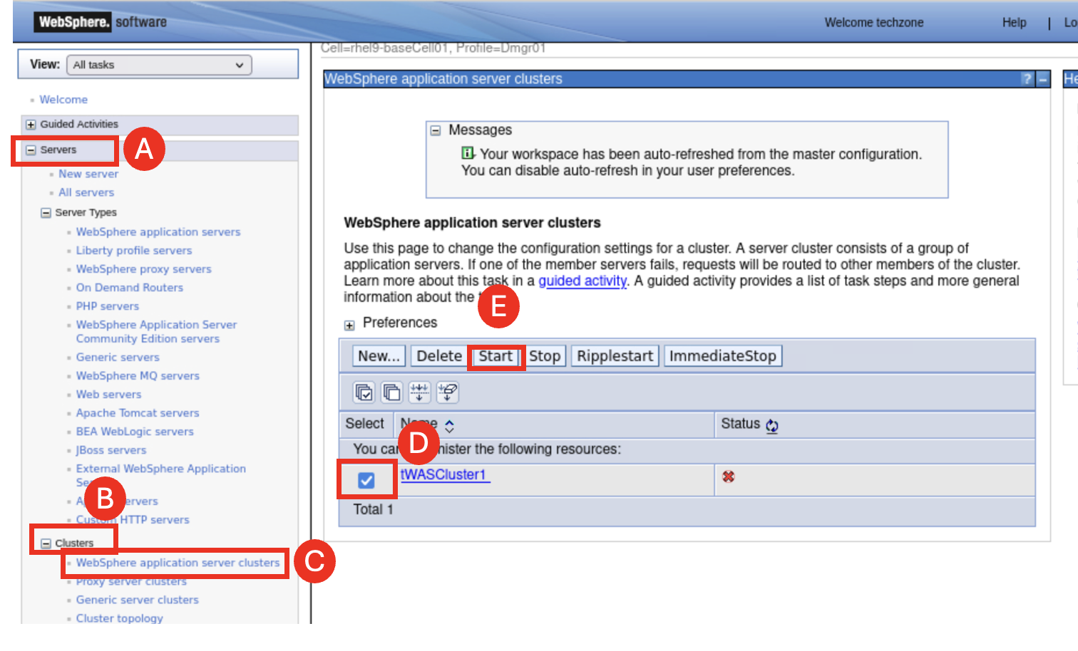

After the **tWASCluster1** gets started, the **WhereAmI** application can be accessed through the default IHS port 8080.

* 1. Access the **WhereAmI** application from the IHS URL: **http://localhost:8080/tWAS/WhereAmI** andthe WhereAmI application page is displayed.

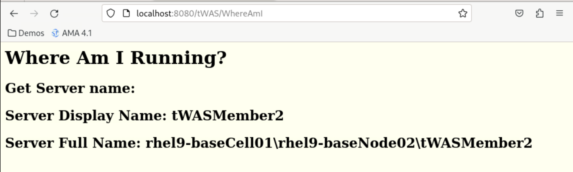

This is a simple application that provides information about which WebSphere server the application is running.

* 1. Click the **page refresh button (A)** a few times, you can see that the displayed information changes between **tWASMember1** and **tWASMember2**, which are the two tWAS members of the **tWASCluster1** cluster.

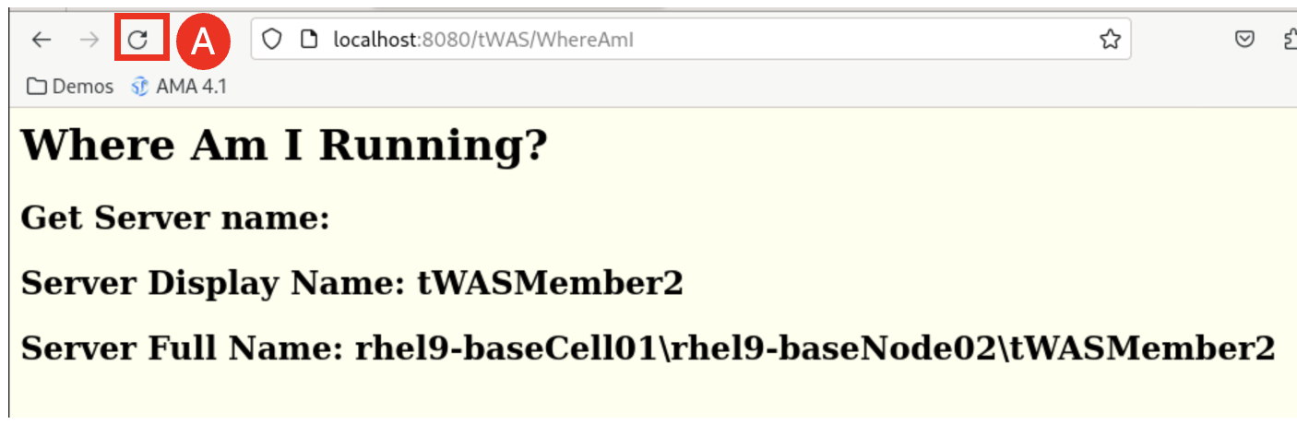

1. Install IBM Application Modernization Accelerator (AMA) local version.

In this section, you are going to learn to process to install AMA local version (4.3.0), which is already downloaded to the lab VM.

* 1. In the **terminal** window issue the following commands to AMA local installation utility.

cd /home/techzone/AMA-local-4.3.0

./launch.sh

click the **Uninstall** (A). DO NOT UNINSTALL ANY COMPONENTS!

* 1. Type **1** and press **Enter (A)**.

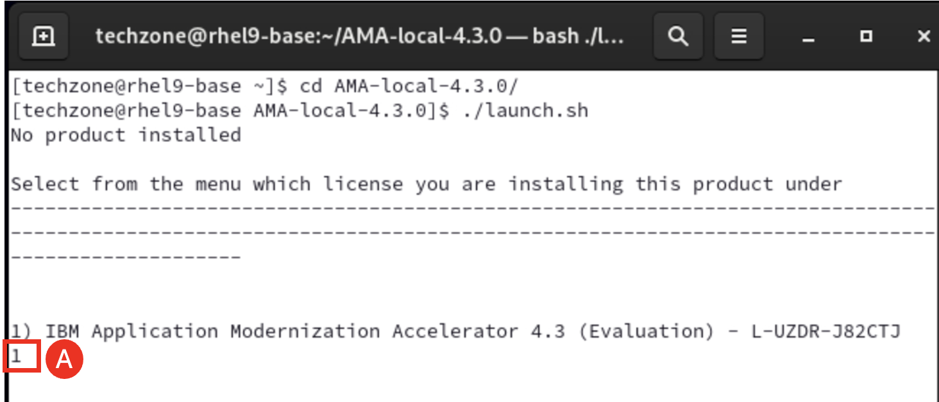

* 1. Type **1** and press **Enter (A)** to accept the license agreement.

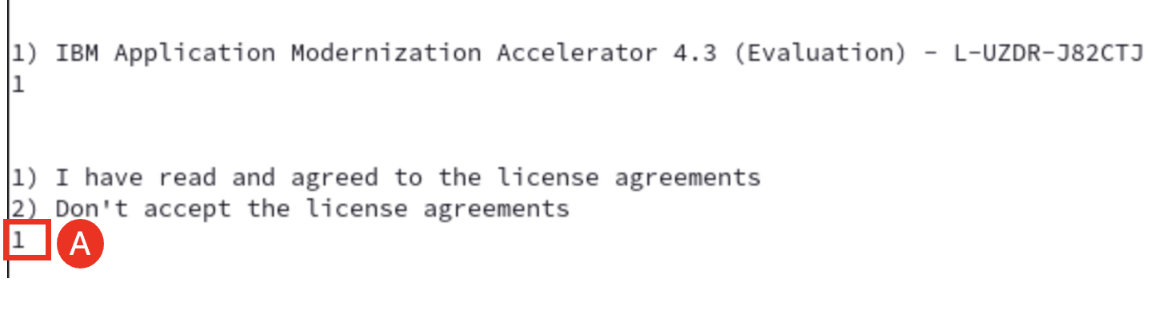

* 1. Type **1** and press **Enter (A)** to start the installation process.

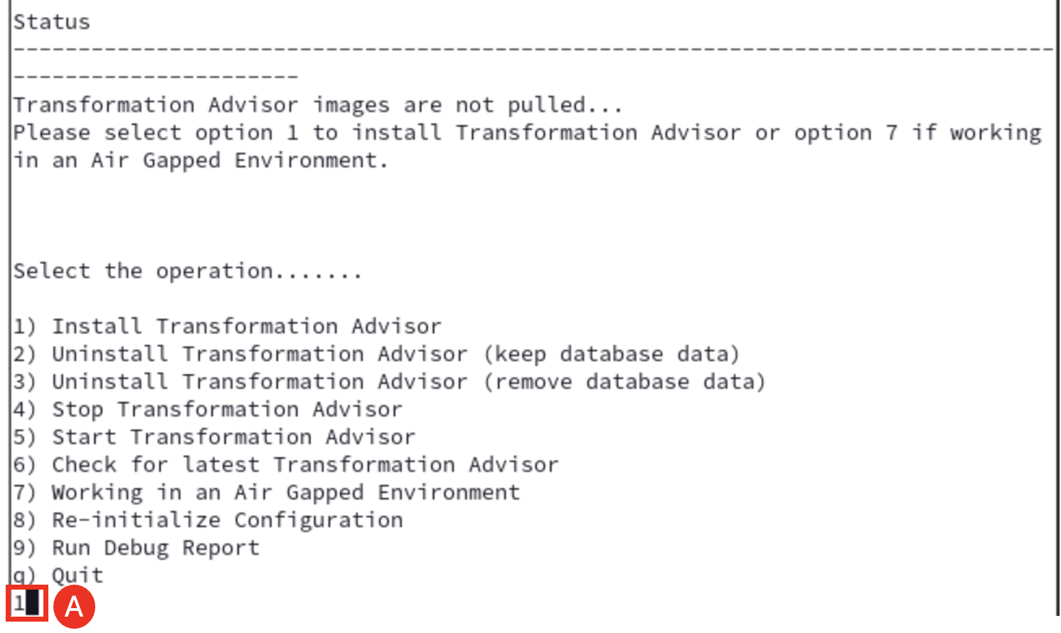

The installation process takes a few minutes to complete. After it is done, it shows that the AMA can be access through its URL. In the following screenshot, the URL is: **https://rhel9-base.gym.lan:443.**

Note: The AMA URL maybe different in your lab environment.

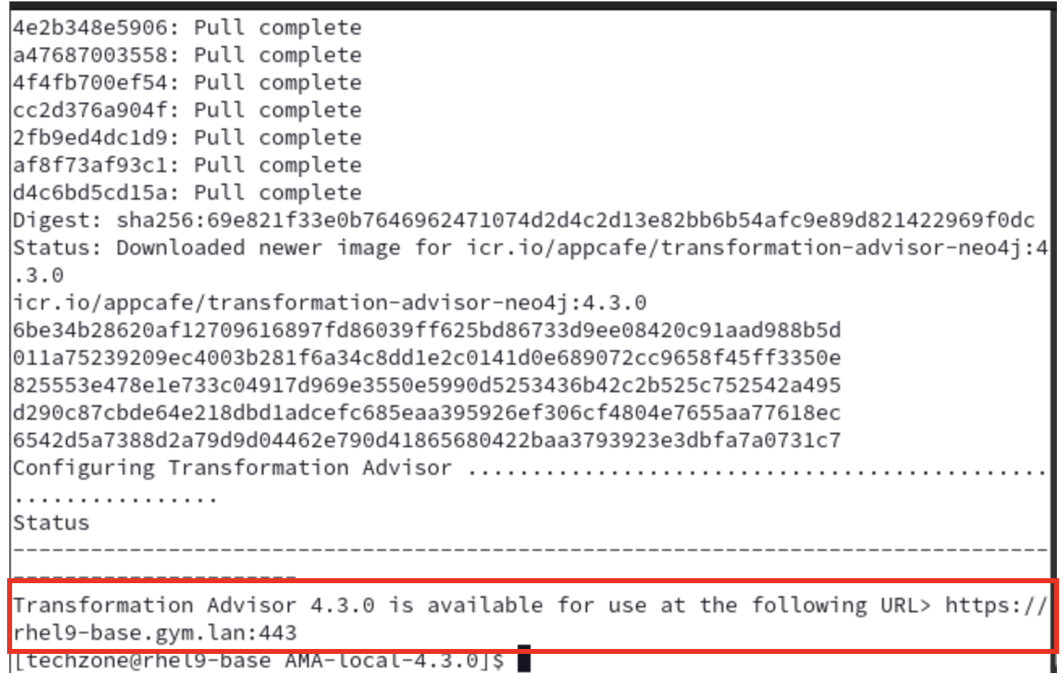

* 1. Right clicking the **AMA URL (A)** and select **Open Link (B)**.

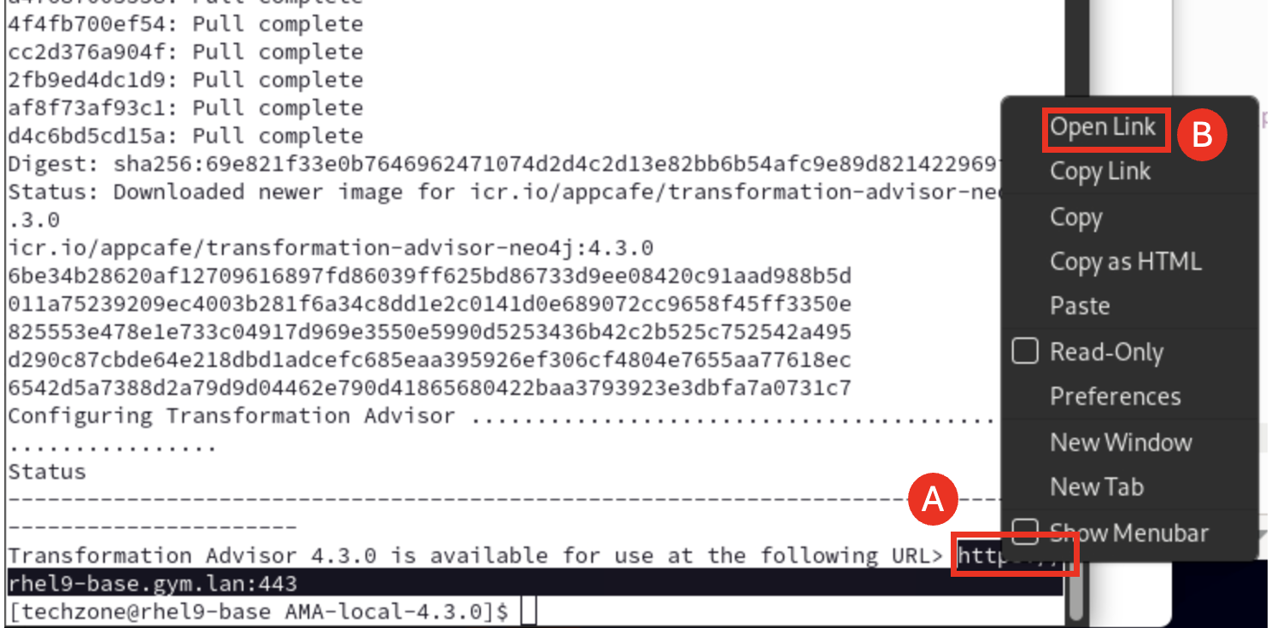

This launches the AMA page in the Firefox web browser window.

Note: If you see the message “Warning: Potential Security Risk Ahead..”, click **Advanced…** then click **Accept the Risk and Continue**.

* 1. In the AMA web page, click **Skip (A)**.

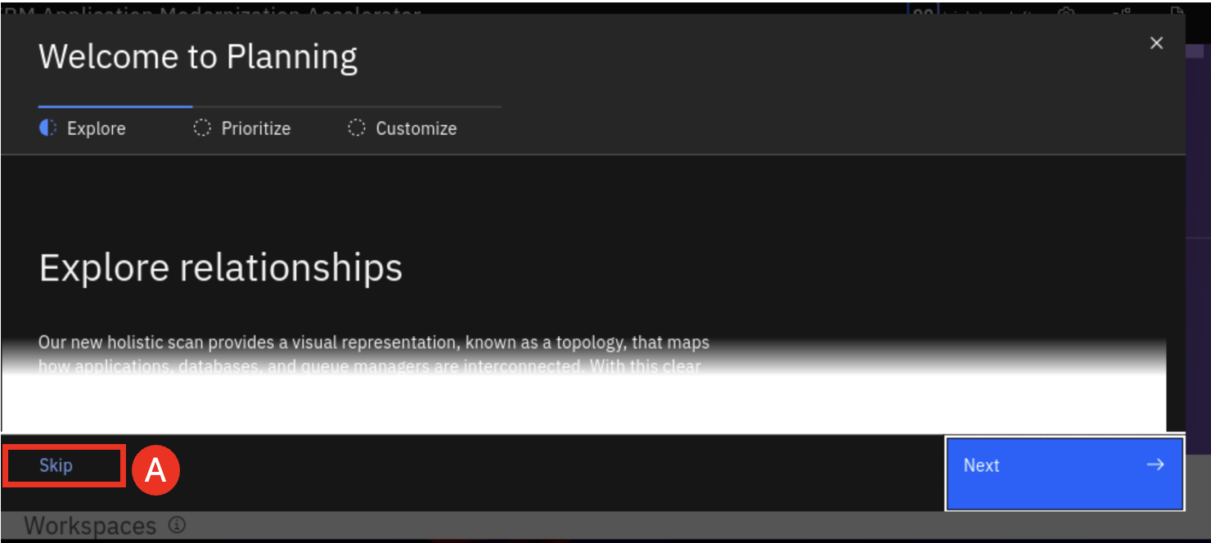

Now you can see the AMA web page.

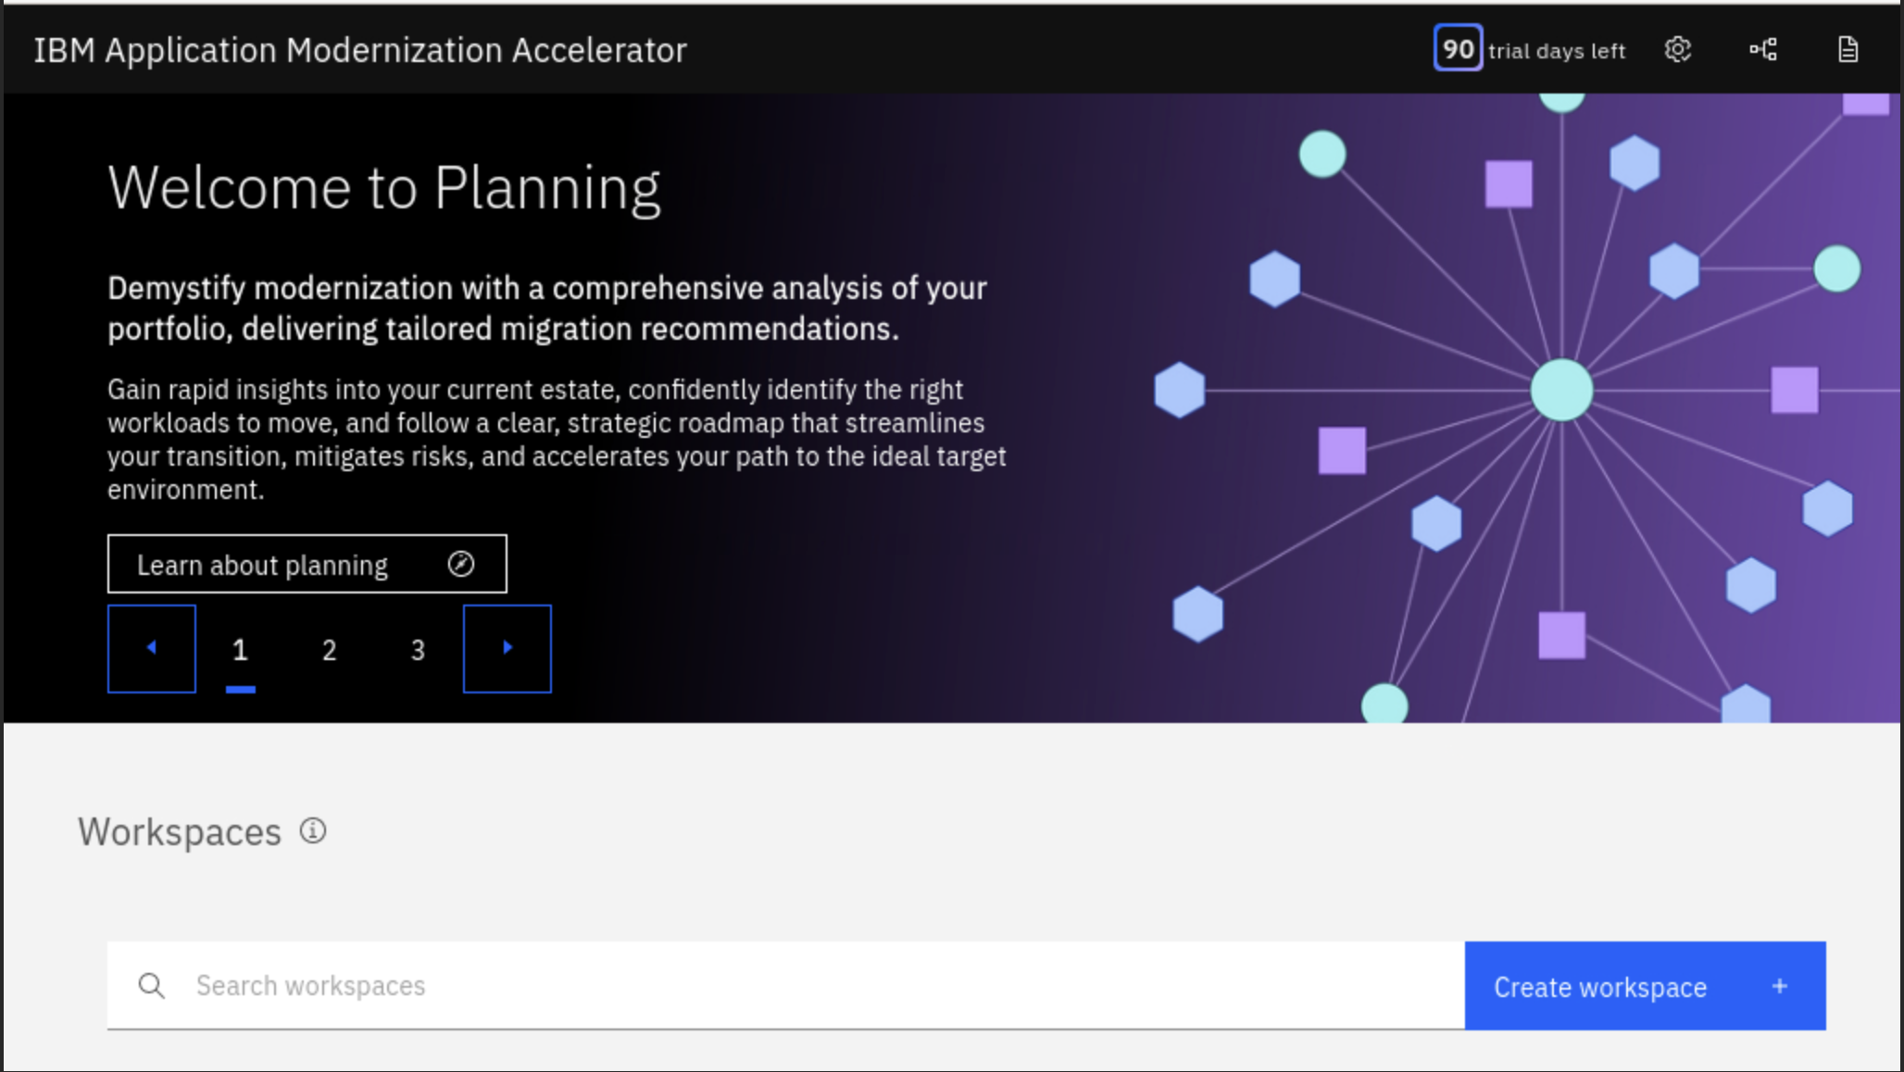

1. Create AMA Workspace.

To use AMA, you need to create an AMA **Workspace** first, which is a designated area that houses the migration recommendations provided by AMA against Java application server environment. In AMA home page, you use **Create workspace** button to create a new Workspace. In this lab, you are going to create a Workspace called **TX2025**.

* 1. Click **Create workspace (A)**.

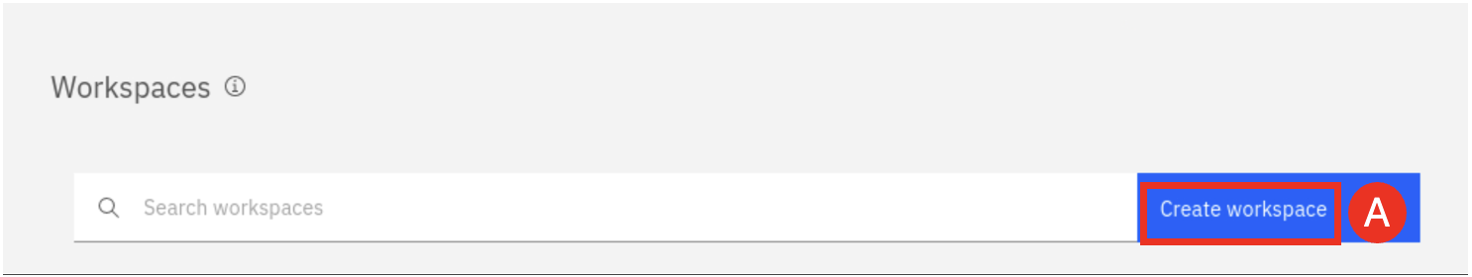

* 1. Enter the Workspace name as **TX2025 (A**) and click **Create (B)**.

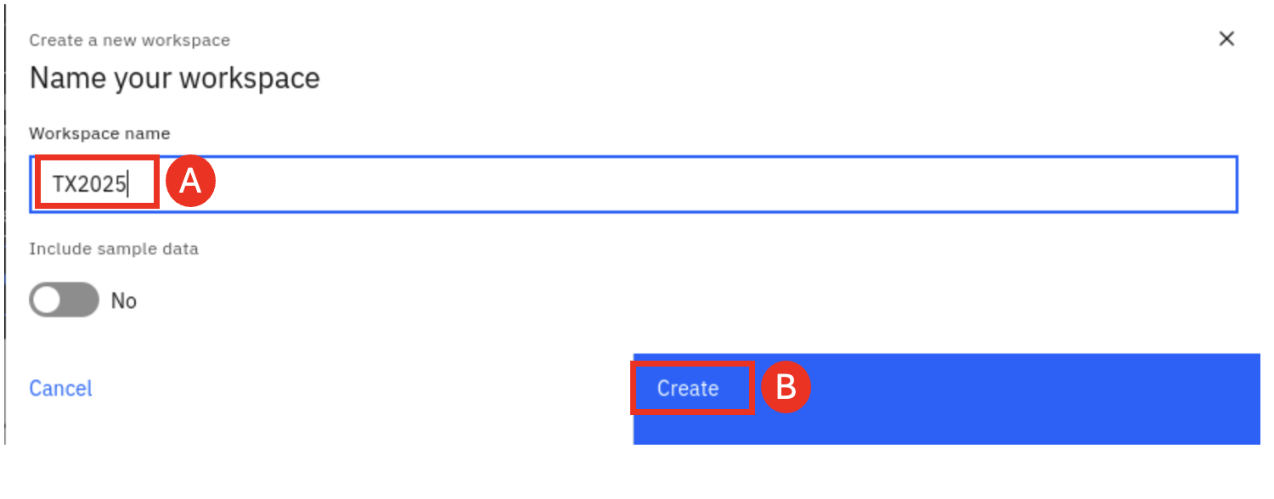

The TX2025 workspace is created.

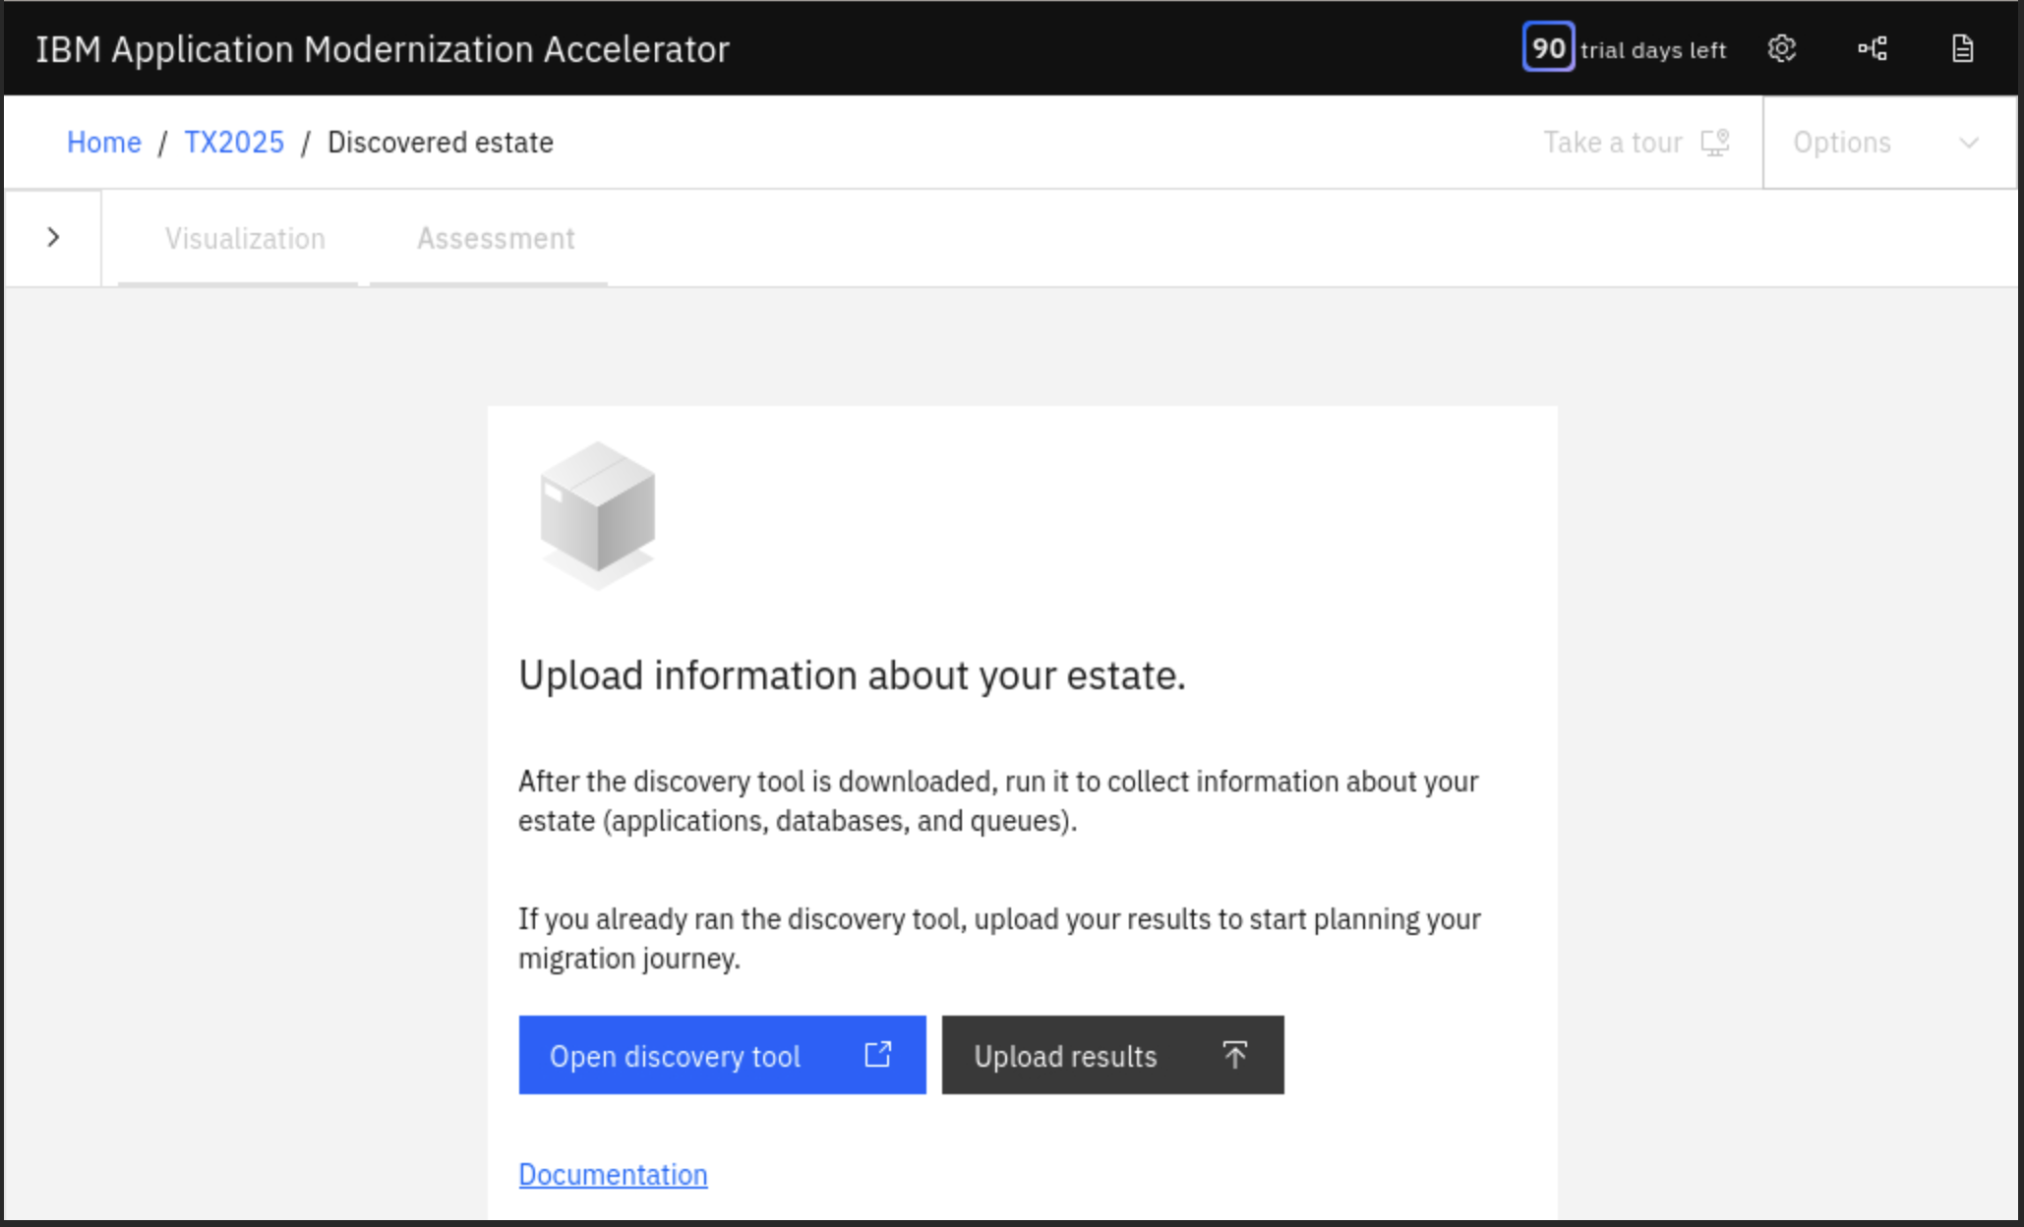

As you can see in the AMA Workspace page, two utilities, **Discovery Tool** and **Data Uploader**, are listed. AMA offers the Discovery Tool utility for getting the application data from the Java application server running in client’s environment. This Java utility can be downloaded from the AMA Workspace page. You can download and run this utility against your Java application server to collect all application data on the server. The utility can send the collected data directly back to AMA, if AMA is in the same network as the application server. It also saves the collected data in a zip file which can be uploaded to a remote AMA using the Data Uploader utility.

1. Download and install AMA Discovery Tool.

After the AMA Workspace is created, you have options to either download the Discovery Tool utility or upload existing data file.

In this lab, you learn how to download and install the Discovery Tool utility. First, you go to the Discovery Tool page and download different version of the utility based on your application server operating system. The Discovery Tool page also shows the information on how to use the utility in command line to collect application data from WebSphere, WebLogic and Tomcat servers.

Next, you save the downloaded utility in your local workstation. This result is a file with a name like **DiscoveryTool-Linux_<WORKSPACE_NAME>.tgz** being downloaded and stored in your workstation **Downloads** directory.

To use the Discovery Tool, you need to extract the Discovery Tool tgz file using the information in the Discovery Tool documentation page. The extracting command unpacks the tgz file and save all Discovery Tool files in a **transformationadvisor-<VERSION>** directory.

* 1. Click **Open discovery tool (A)**.

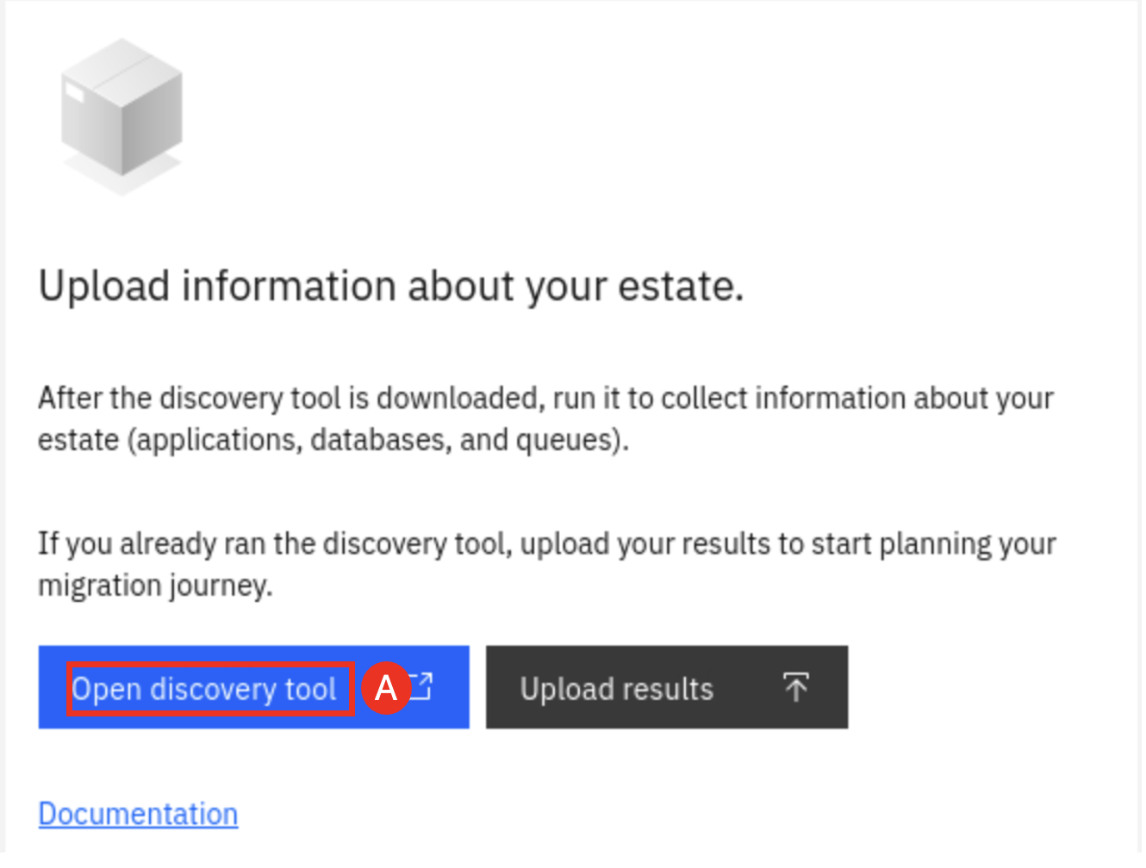

The Discovery tool page is displayed.

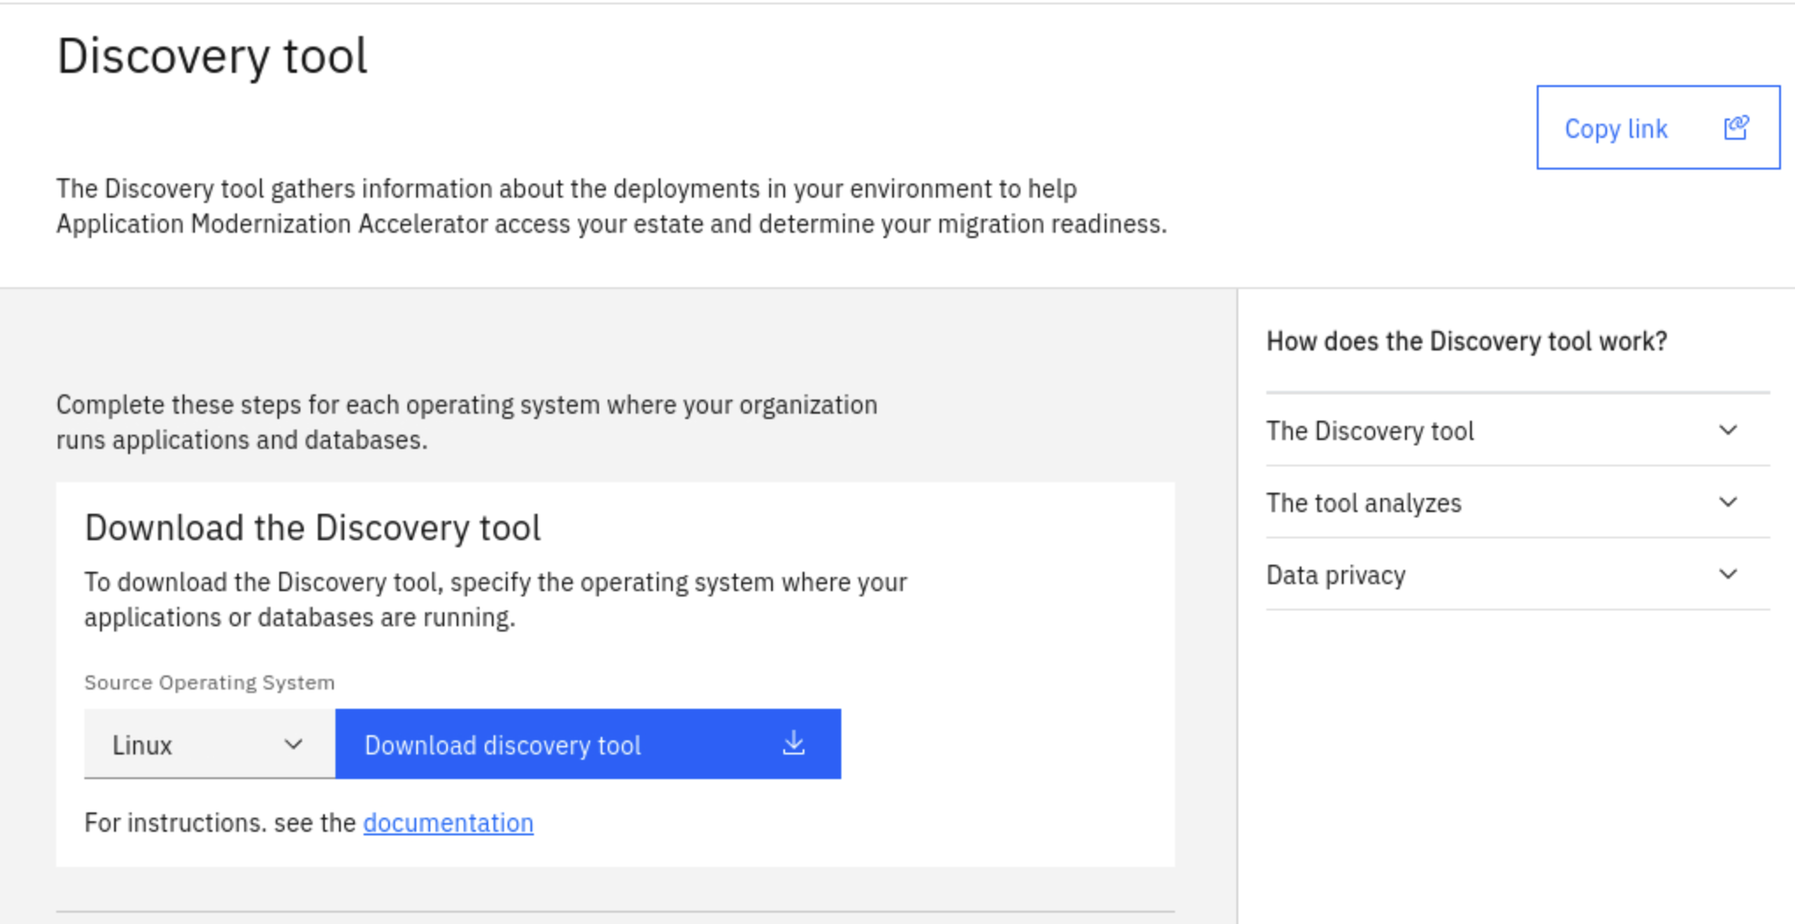

Here you can download the utility based your application server operating system. It also provide information on how the Discovery tool works and a documentation link.

* 1. Click **Download discovery tool (A)** to download the Linux version of Discovery tool, because the lab VM is the Linux operating system.

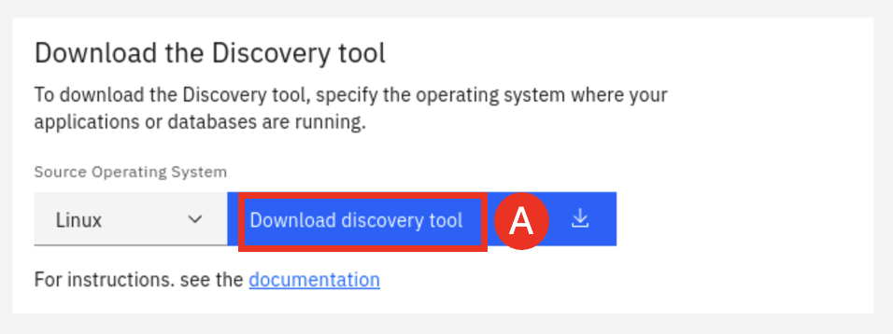

Note: If you see the message “Warning: Potential Security Risk Ahead..”, click **Advanced…** then click **Accept the Risk and Continue**.

The Discovery tool file named **DiscoveryTool-Linux_TX2025.tgz** is downloaded to the **/home/techzone/Downloads** directory.

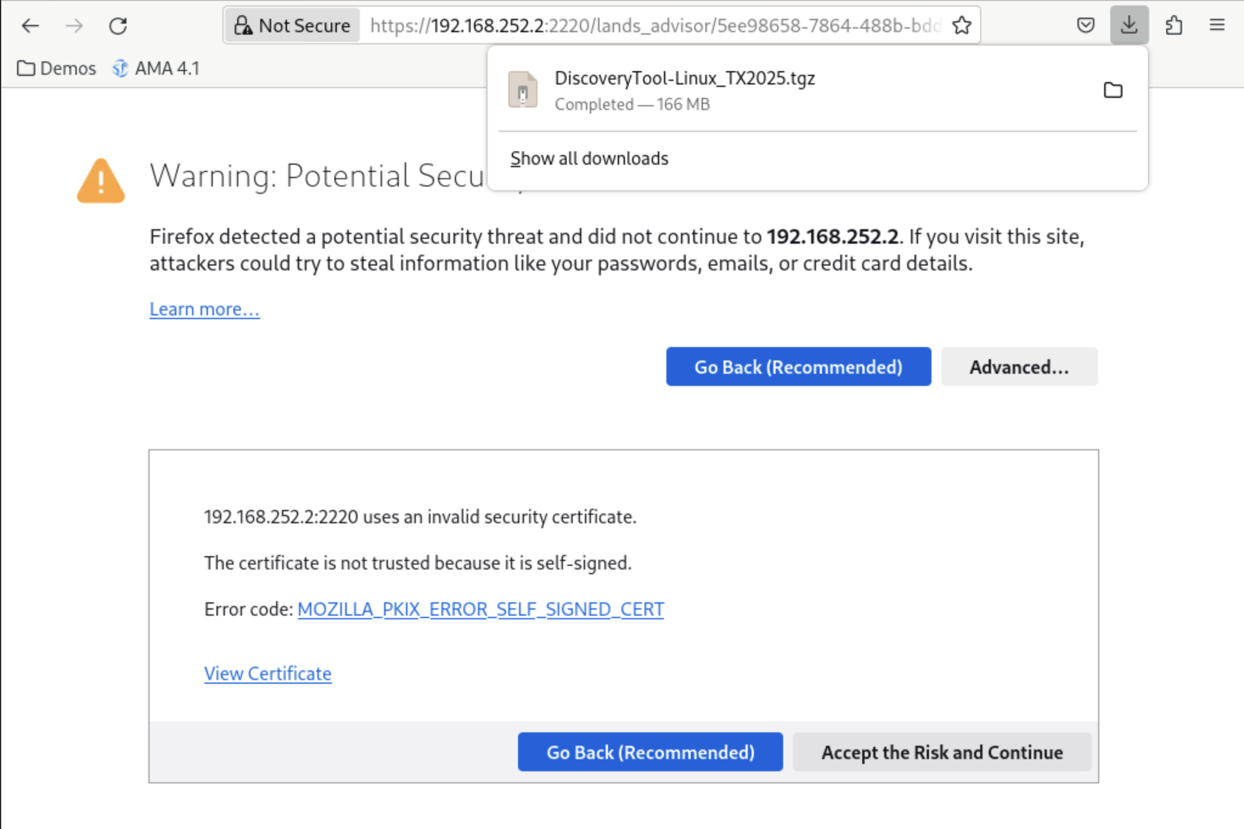

* 1. After the Discovery tool is downloaded, click **Go back icon (A)** two times to get back to the AMA Discovery tool page

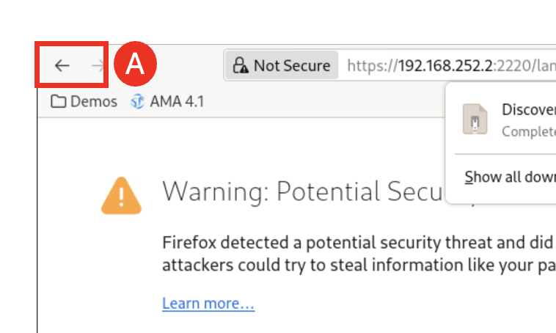

* 1. In the Discovery tool page, right-click **documentation (A)** and select **Open Link in New Tab (B)**.

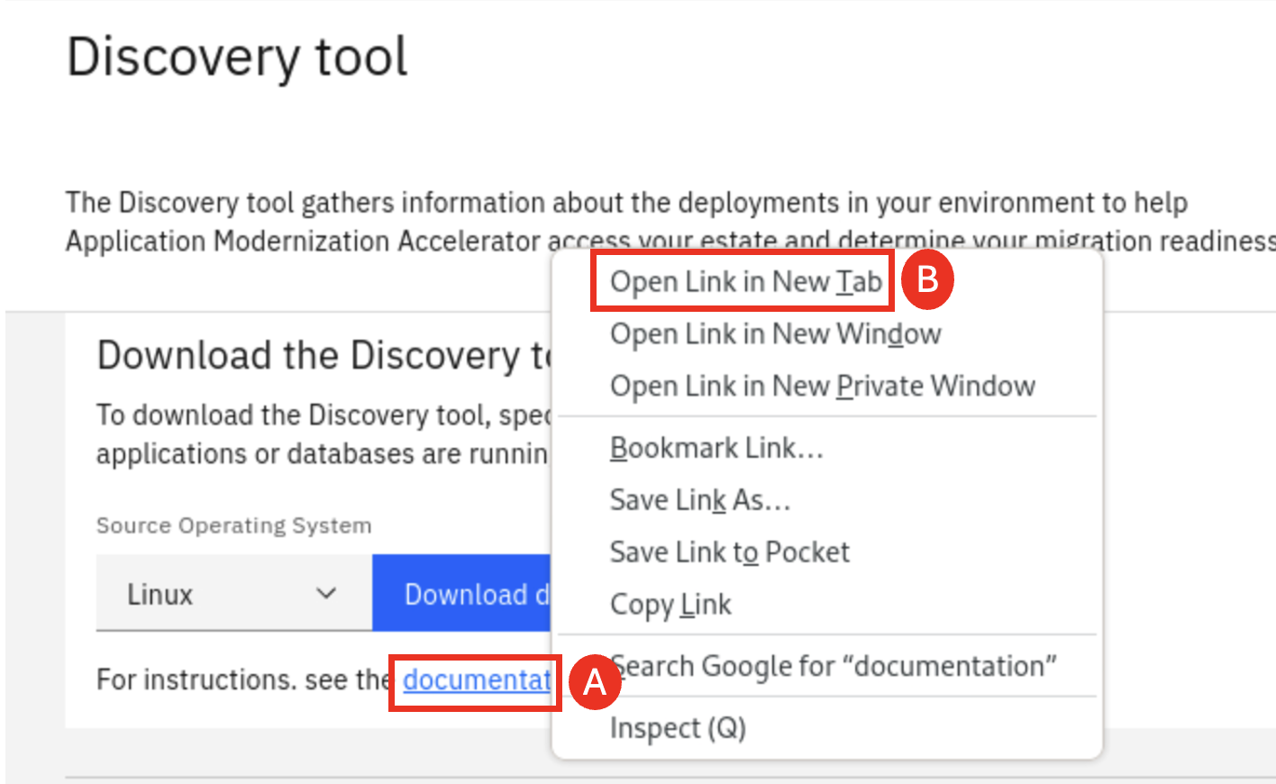

* 1. In the documentation page, **scroll down (A)** to the **Installing the discovery tool** section to learn the commands used to install the utility.

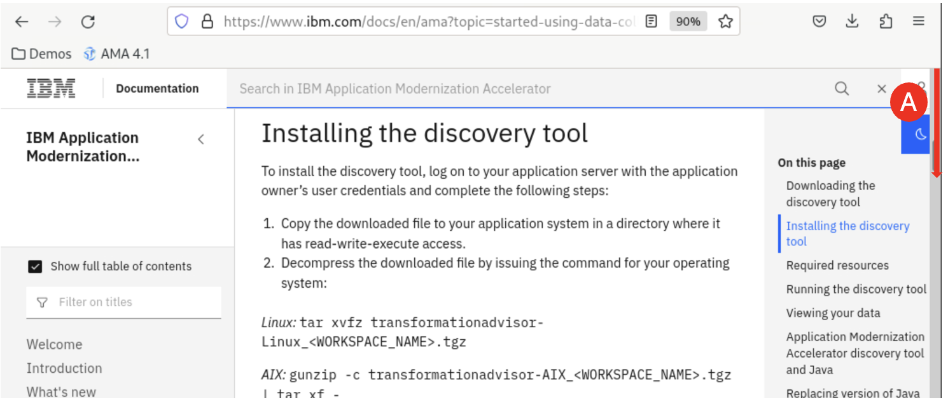

* 1. From the terminal window, issue the following commands to install the utility.

cd /home/techzone/Downloads

tar xvfz DiscoveryTool-Linux_TX2025.tgz

This extracts the AMA Discovery Tool utility to the **/home/techzone/Downloads/transformationadvisor-4.3.0** directory.

Now the AMA Discovery Tool is installed, you can run it against your application server. The AMA Discovery Tool documentation page provides detail information on how to run the tool.

The tool can collect data from different application server runtimes, including WebSphere, WebLogic, JBoss, Tomcat and DB2. It also can narrow the analysis scope at different levels, either on application and configuration, or on application only or on ear/war files.

1. Using the AMA Discovery Tool against the tWAS cell via command:

cd /home/techzone/Downloads

transformationadvisor-4.3.0/bin/transformationadvisor -w /home/techzone/IBM/WebSphere/AppServer/

* 1. Type **1** andpress **Enter (A)**.

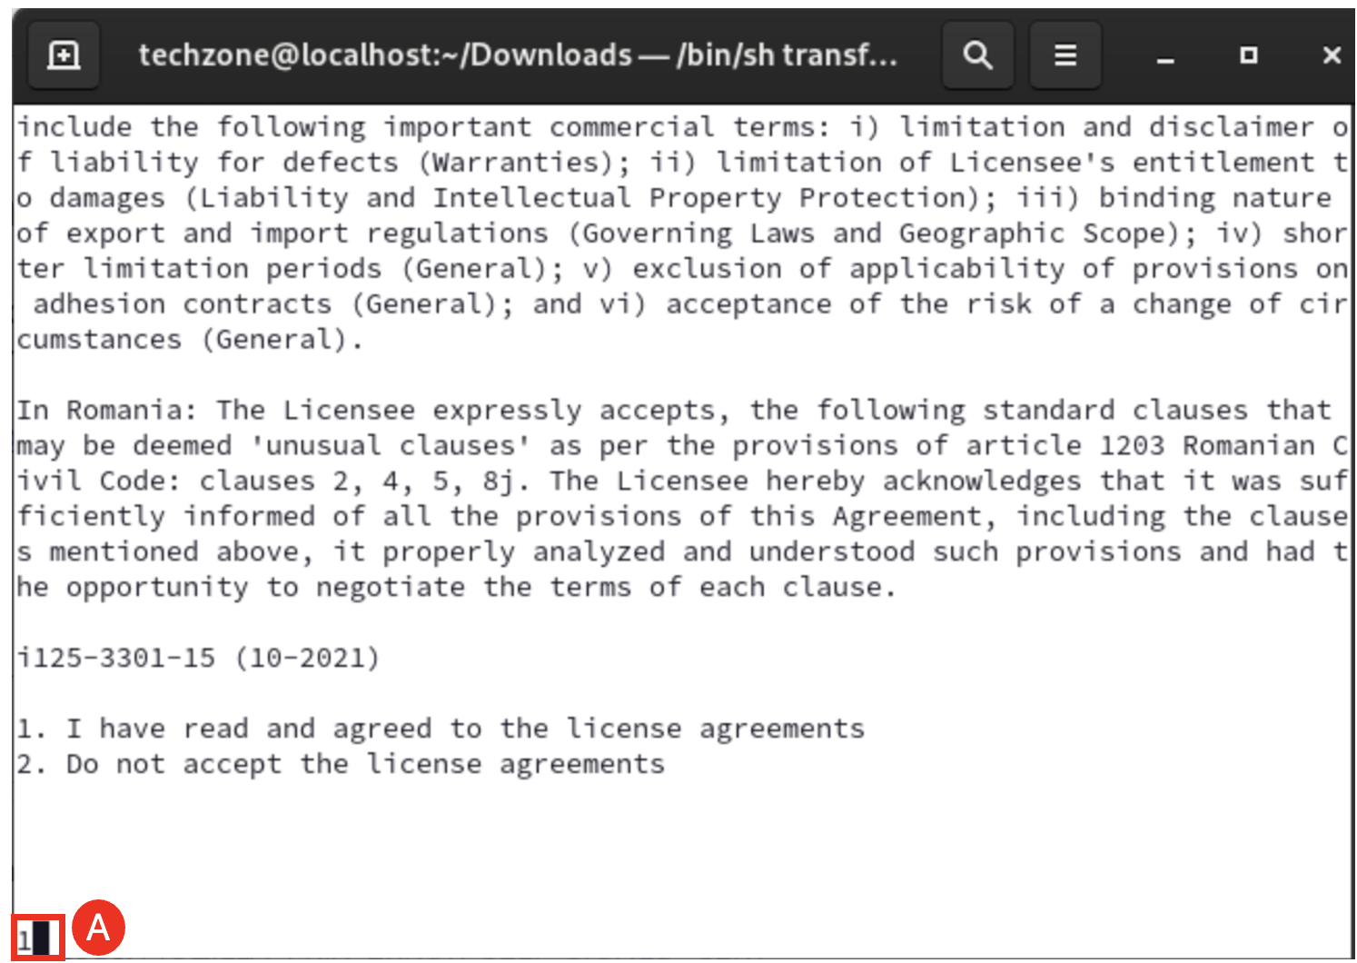

The discovery tool will start to scan the WebSphere environment.

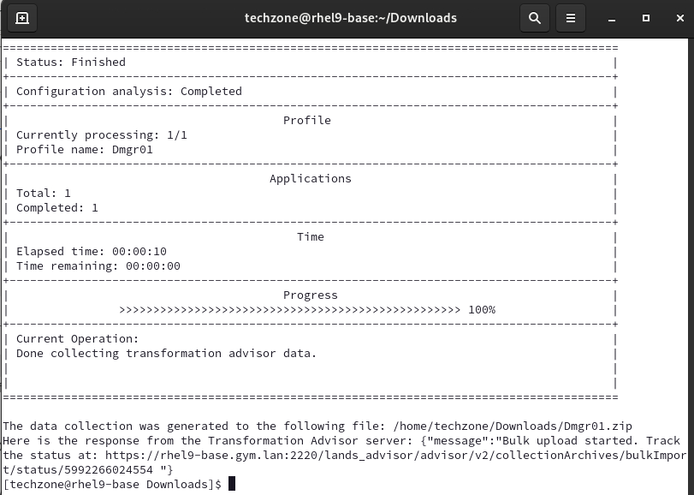

Wait until the collection has been uploaded and is available in AMA.

1. Evaluate the **WhereAmI** application with AMA.

After the Data Collector results have been uploaded to AMA, a set of recommendations are created, you can go through to check them out.

* 1. In the AMA Discovery Tool page, click the workspace **TX2025 (A)** to go back to the workspace page.

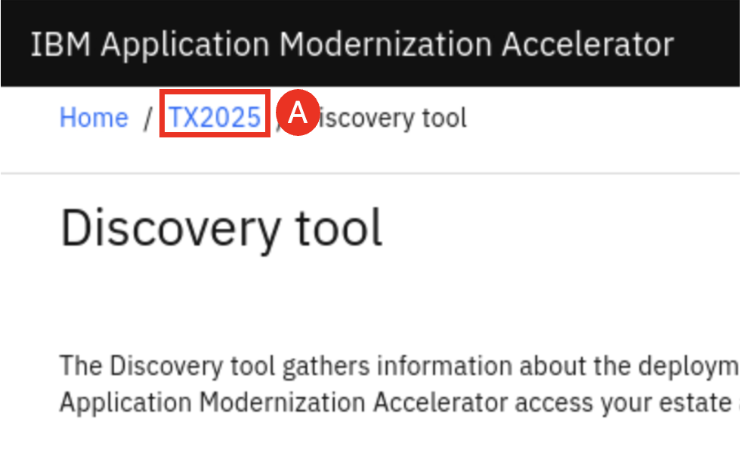

You can see that the data collected by the AMA Discovery Tool is now uploaded to AMA Workspace page.

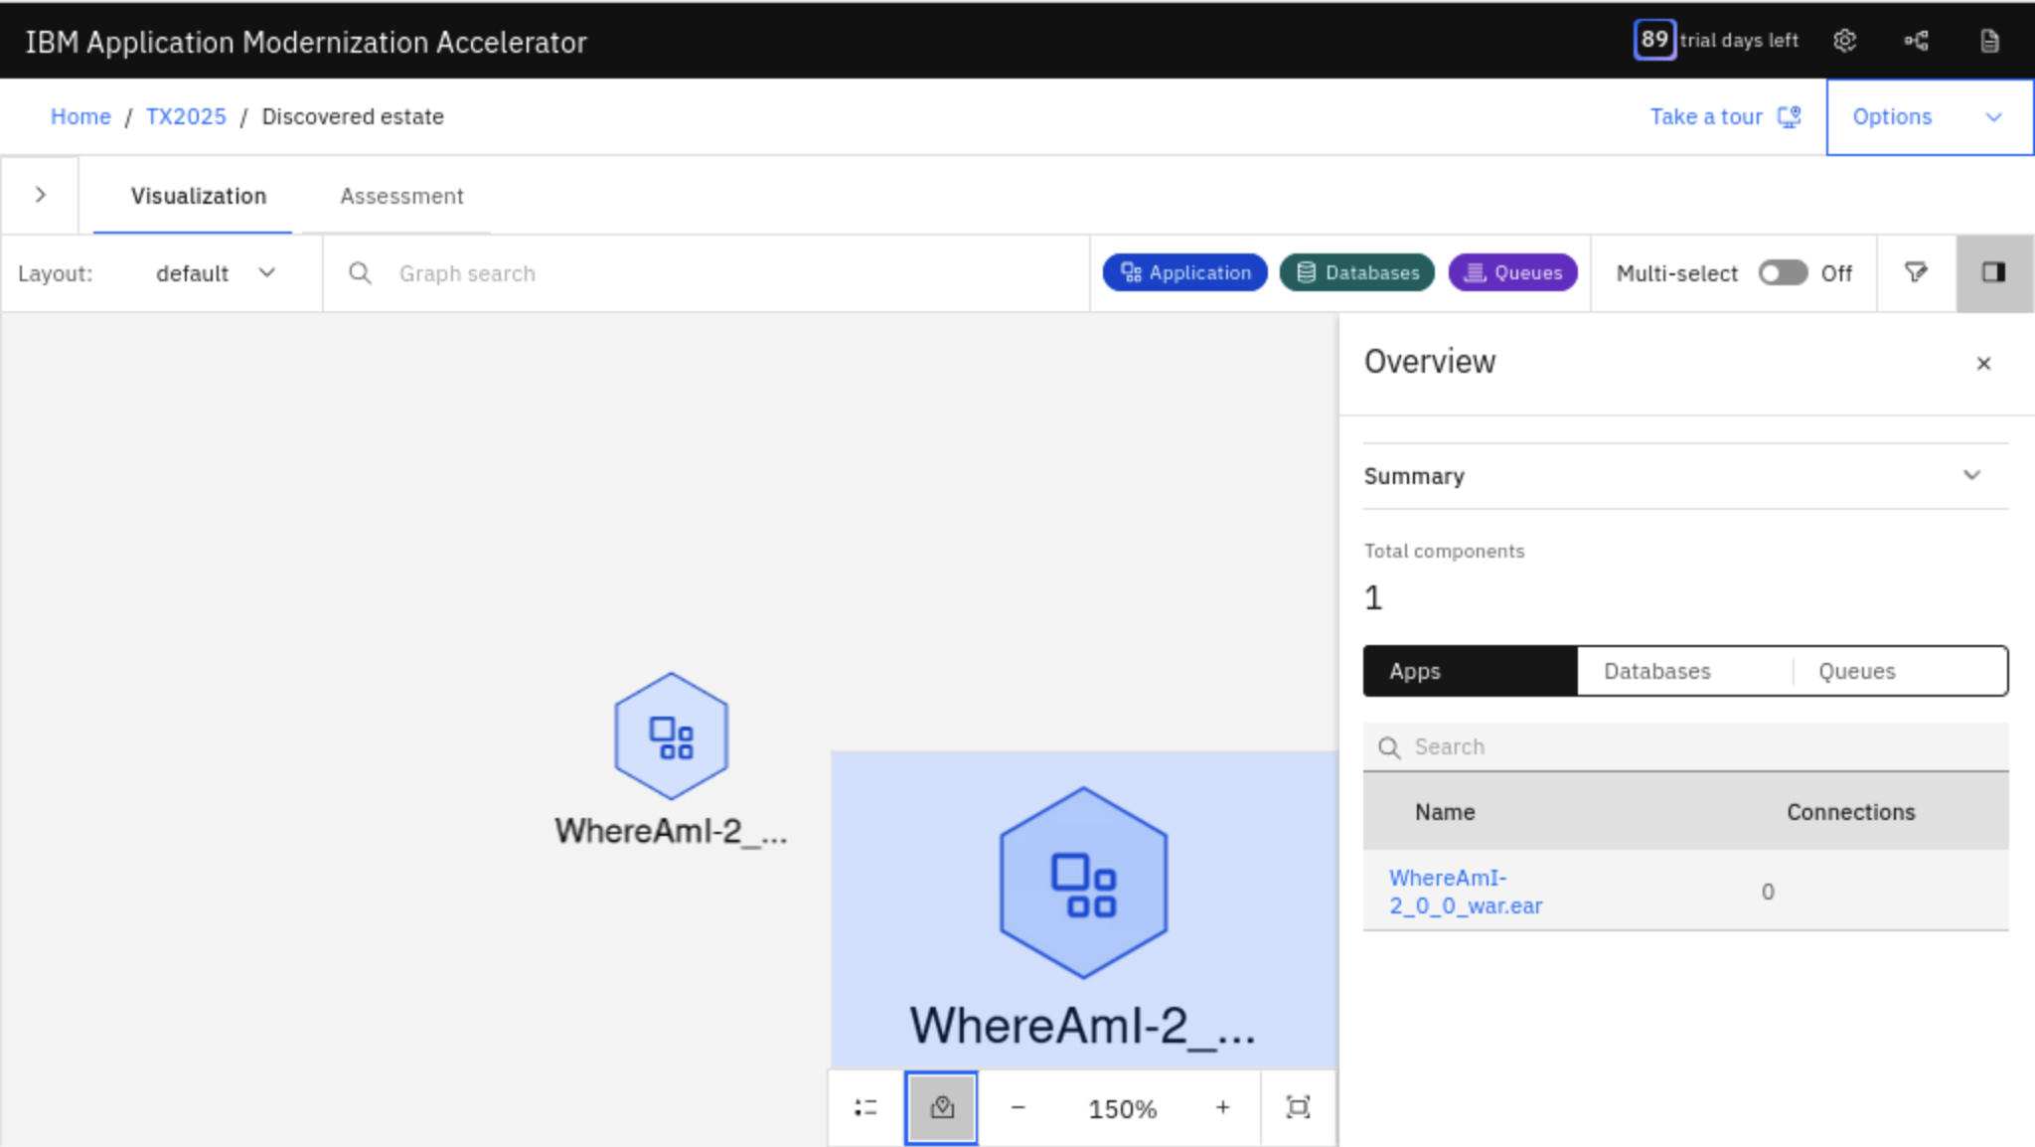

You can see that the **WhereAmI** application version 2.0.0 is showing in the **Visualization** tab and there are no dependencies to other applications, databases or queues.

* 1. Click **Minimize icon (A)** to minimize the Context window.

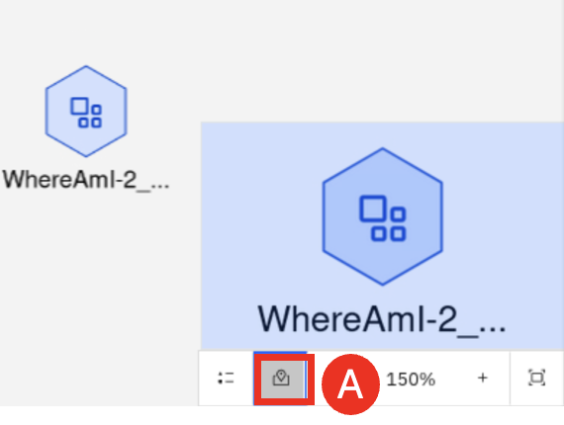

* 1. Click **Assessment tab (A)**.

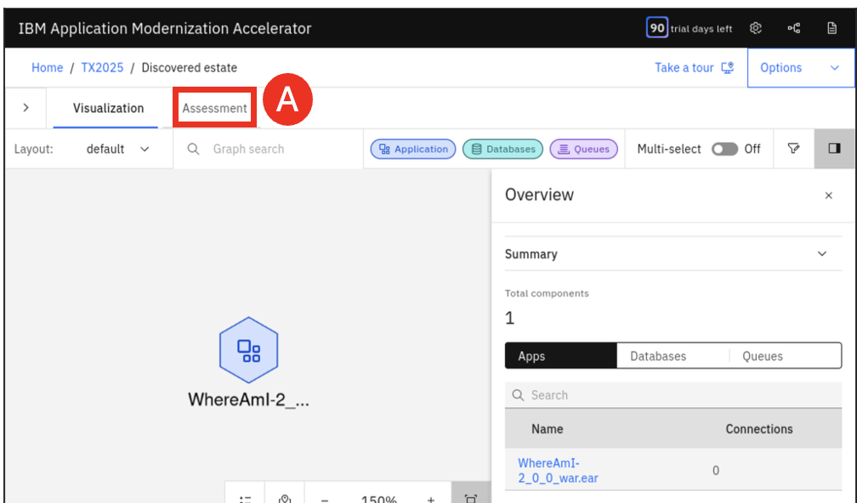

* 1. Select the **Target destination** as **Liberty administered from WebSphere (MoRE) (A)**.

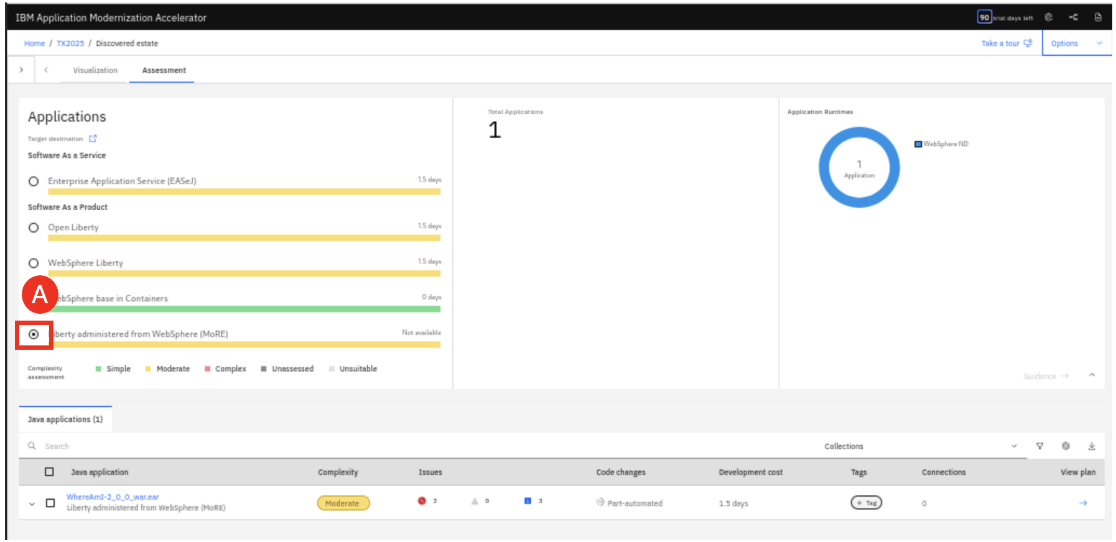

As you can see, the application can be migrated to MoRE but there are some issues that must be fixed.

* 1. Click **WhereAmI application (A)** in the Java applications list to get more insight about its issues.

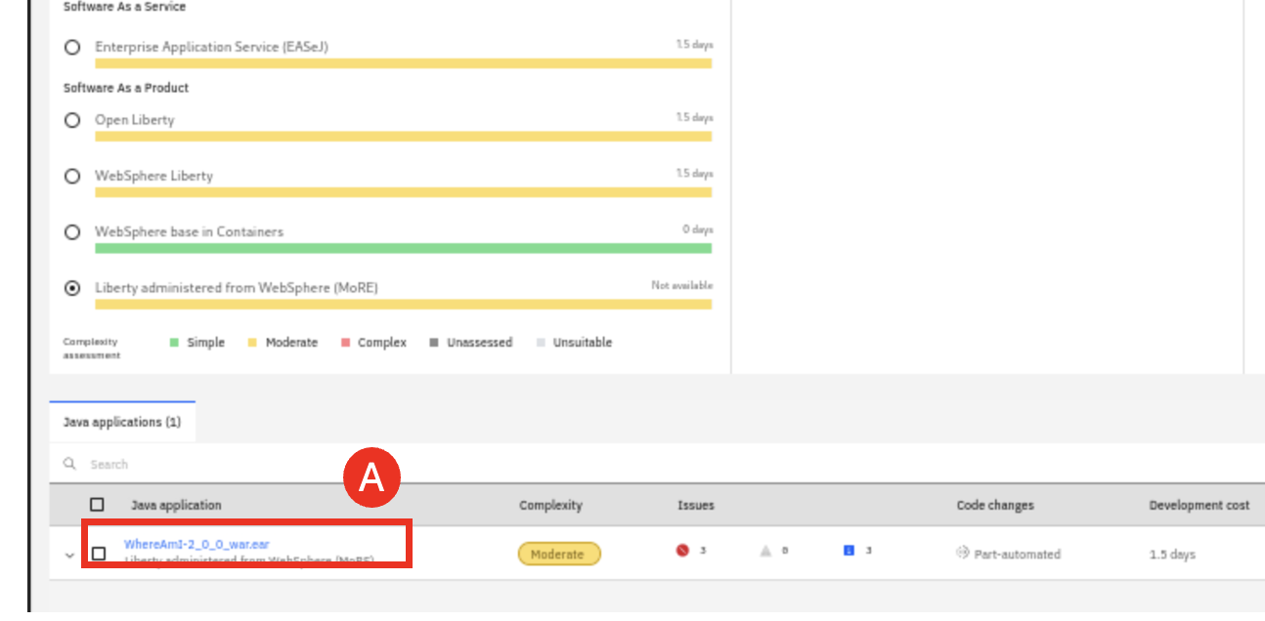

The **WhereAmI** application analysis details page is displayed.

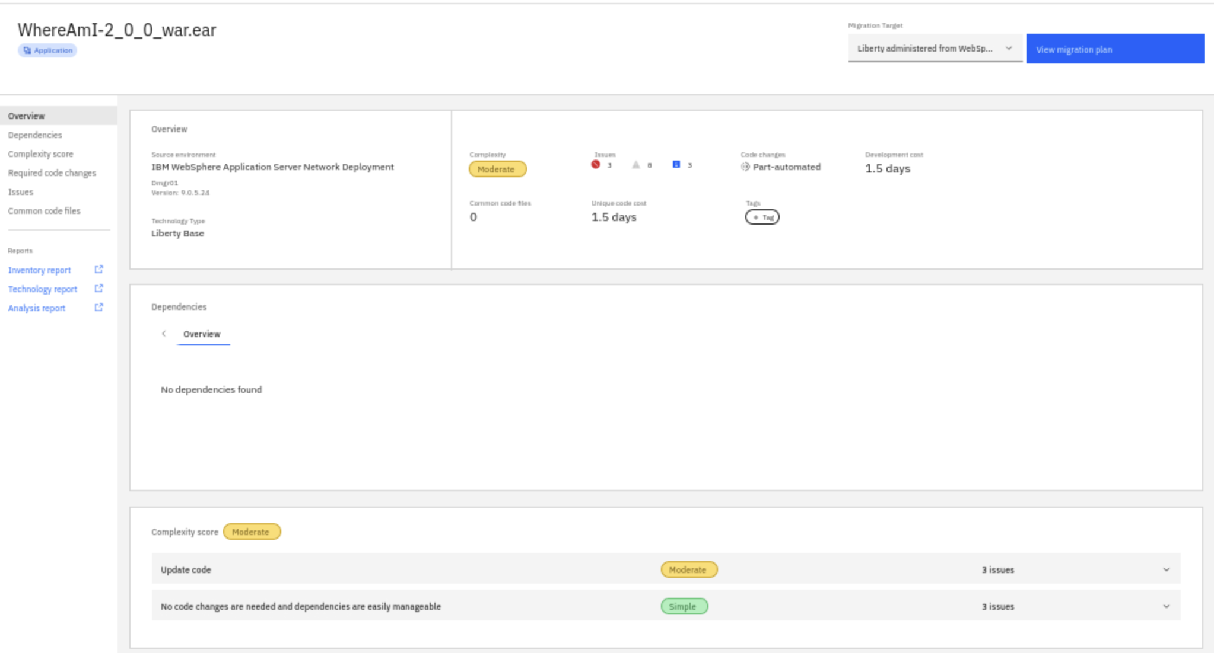

You can see that:

The target environment is **MoRE**, and the source environment is **IBM WAS ND**. The application is marked with a Complexity of **Moderate** and with Code changes **Part-automated**. The Complexity score section shows that there three **Critical** issues and three **Information** issues. Issues are marked as **Critical** indicate that code changes need to be done before the application can run on **Liberty administered from WebSphere (MoRE)**. Issues marked as Informational indicate that the code is expected to work, but might behave in unexpected ways, so it is recommend to look at these issues if problems are found during testing.

The **Part-automated** code change means that these codes changes are partially automated and some manual code changes are needed.

The estimated effort to move the application to **MoRE** is 1.5 days.

* 1. Expand the **issue sections (A)**, you can see that the three critical issues requires application code changes.

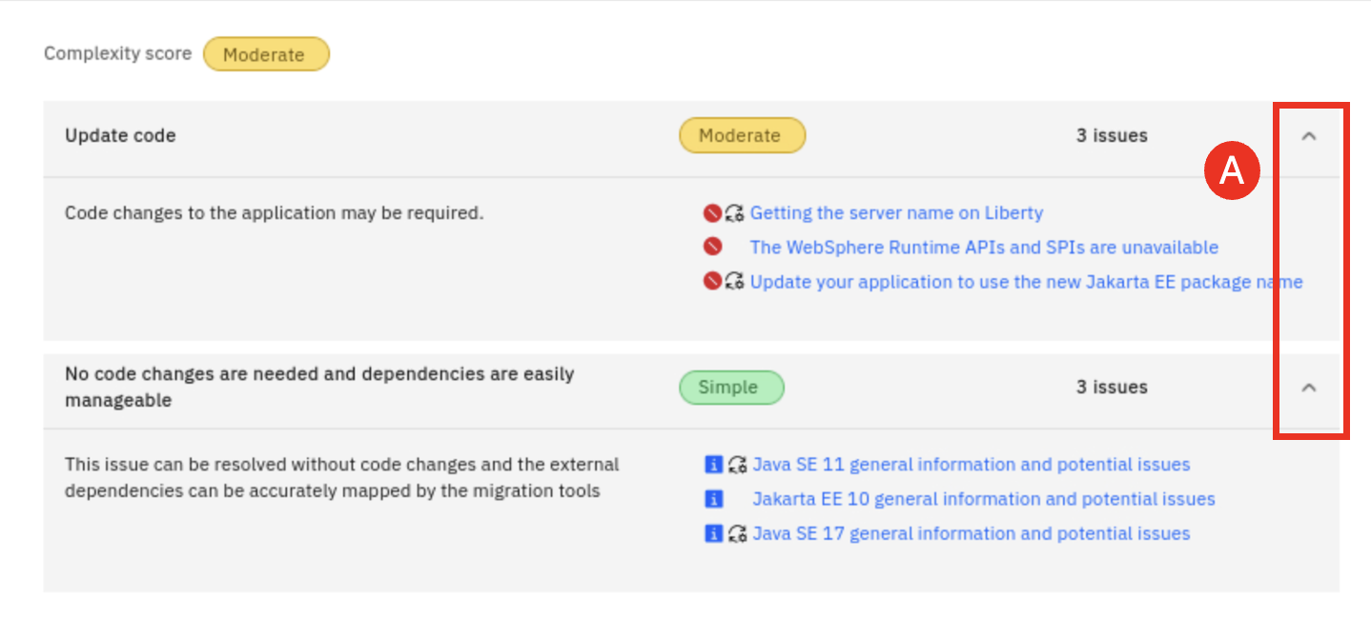

* 1. Click **Getting the server name on Liberty link (A)** to review the first critical issue.

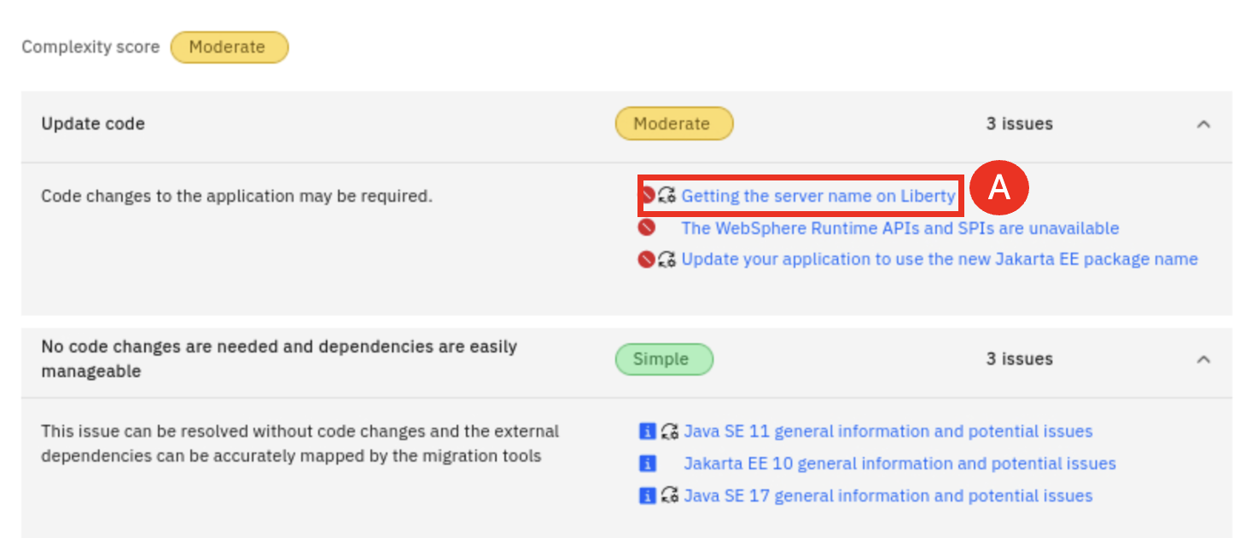

The issue detail is summarized and **Issue help** provides recommendations on how to address the issue.

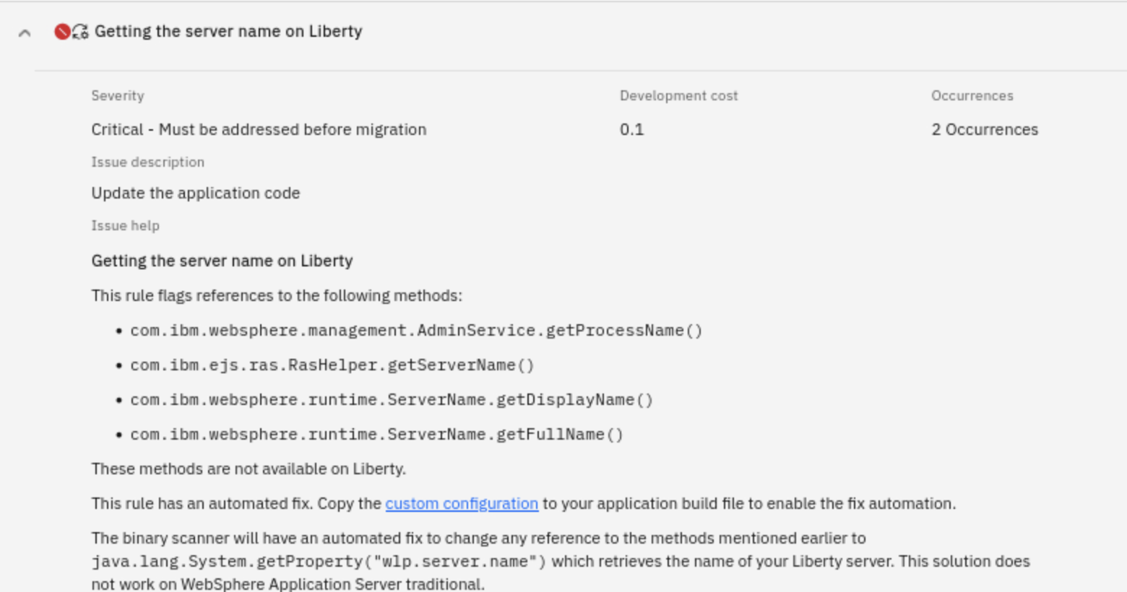

* 1. On the left-hand side click **Required code changes** **(A)**.

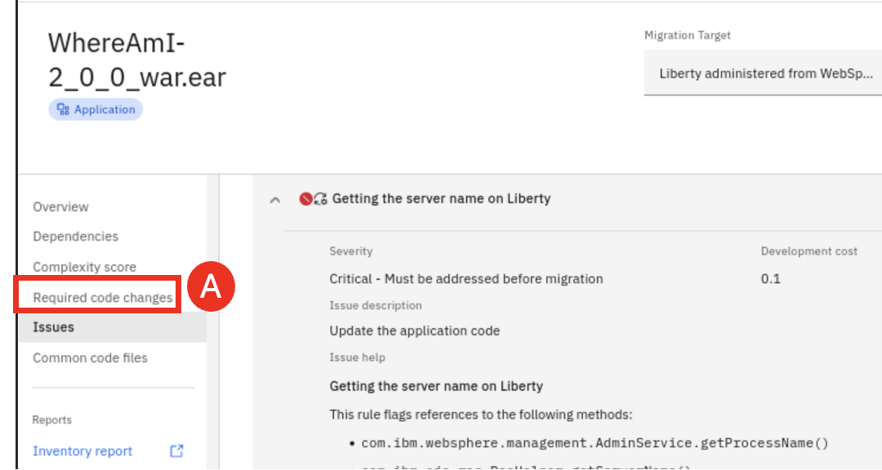

The screen scrolls to the Required code change section and you can see how to access the necessary recipes to apply the required code change automatically.

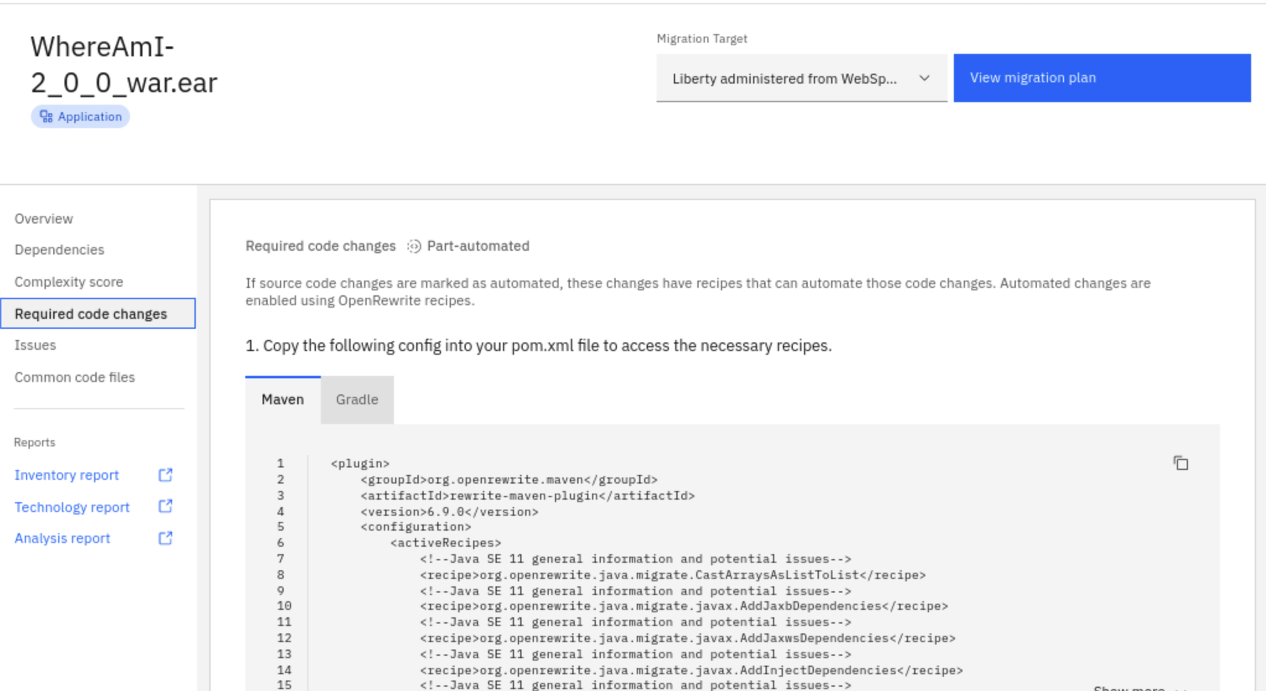

* 1. AMA creates three reports that provides more analysis results, including **Inventory report**, **Technology report** and **Analysis report**. Click **Inventory report (A)** to review it in a different browser window.

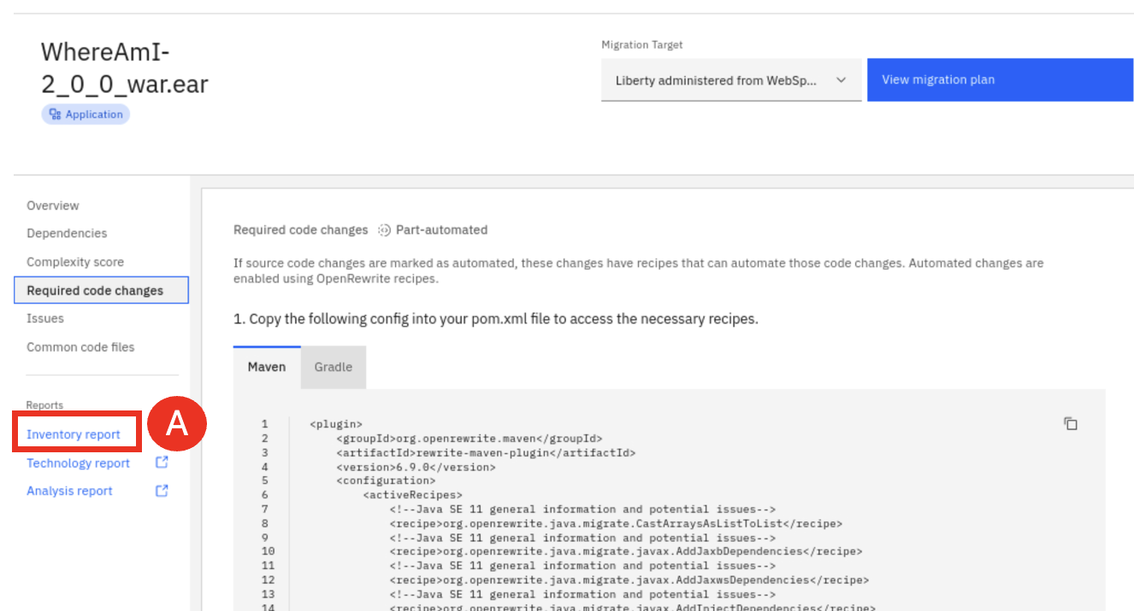

The **Inventory report** lists high-level inventory of the content and structure of each application, plus information about potential deployment problems and performance considerations.

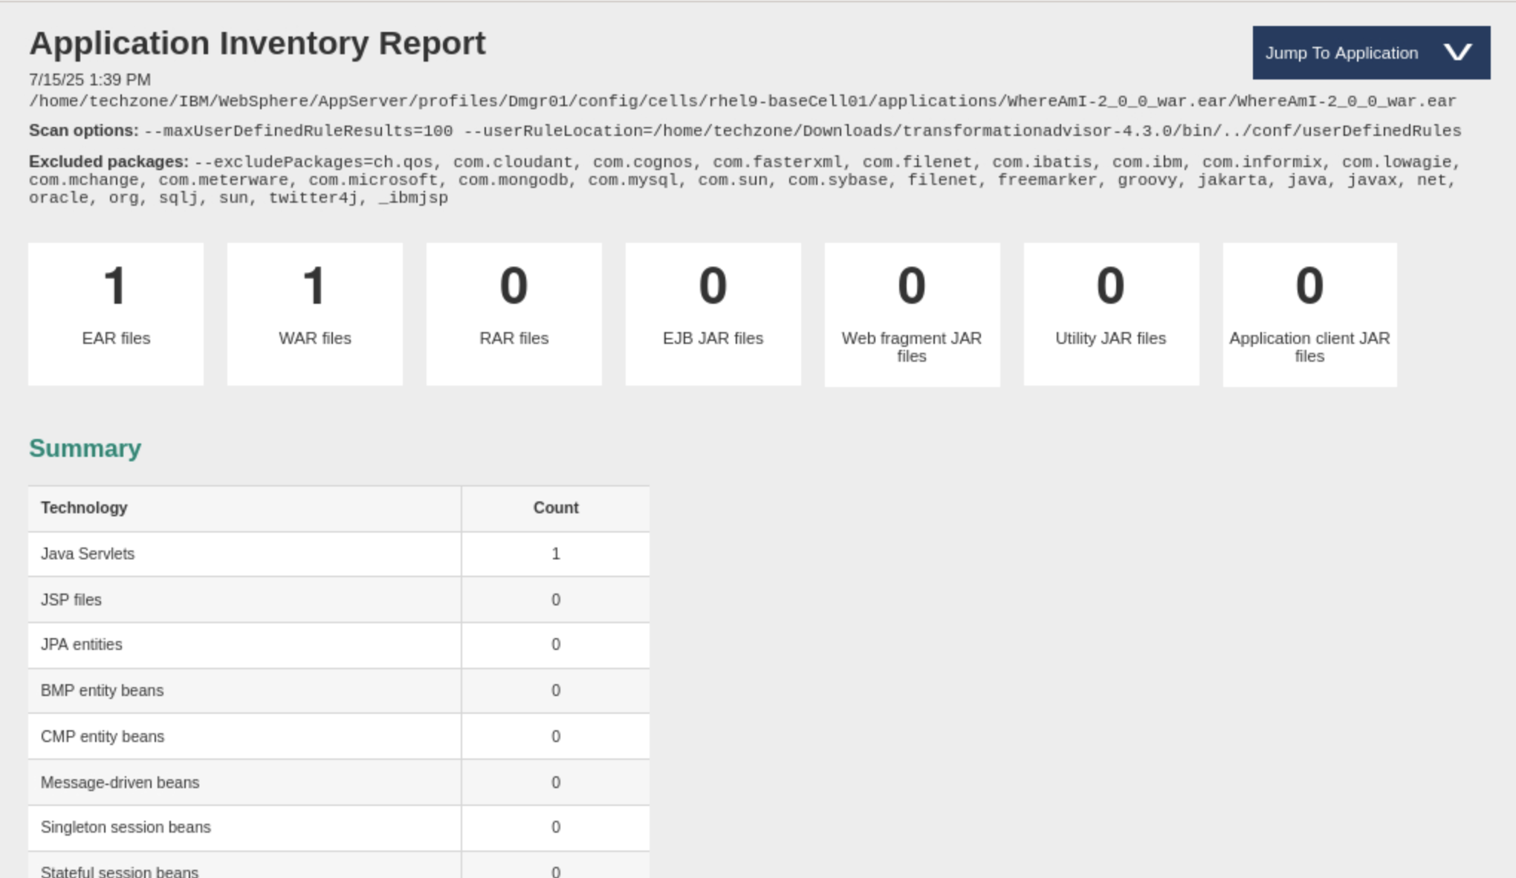

* 1. Click **Technology report (A)** to review it in a different browser window.

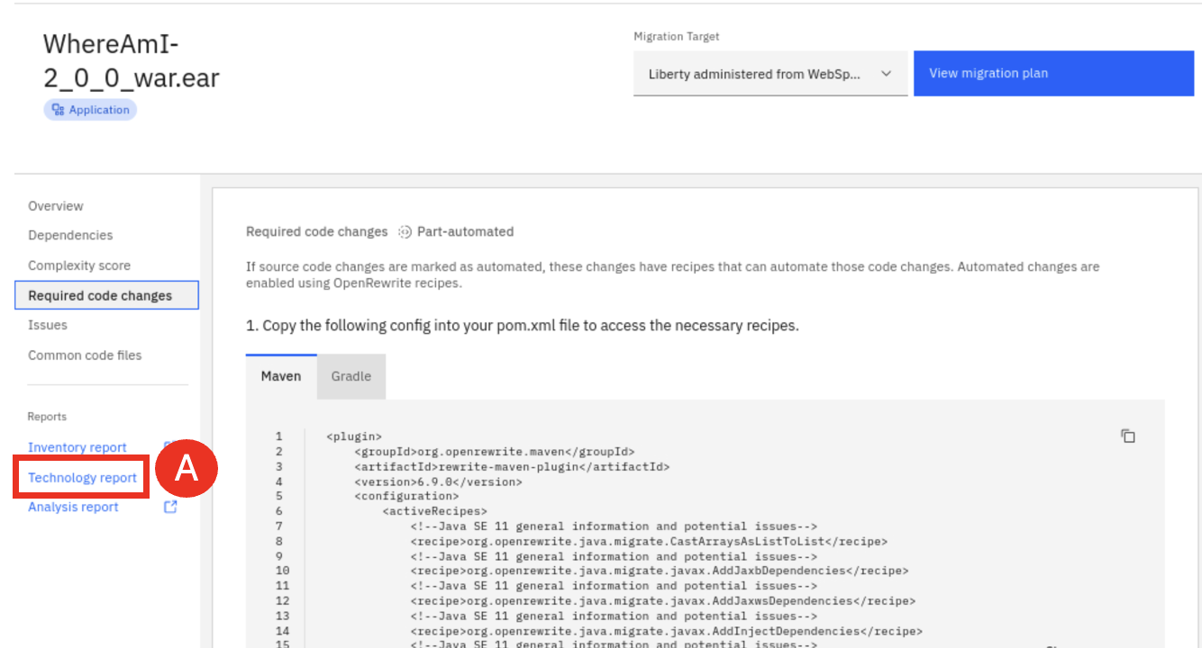

The Technology report provides details on which IBM platforms support the technologies used by the applications.

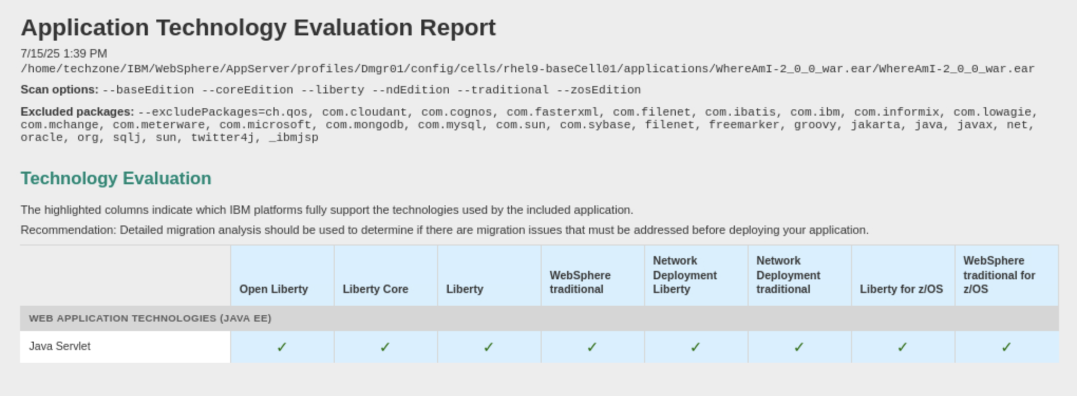

* 1. Click **Analysis report (A)** to review it in a different browser window.

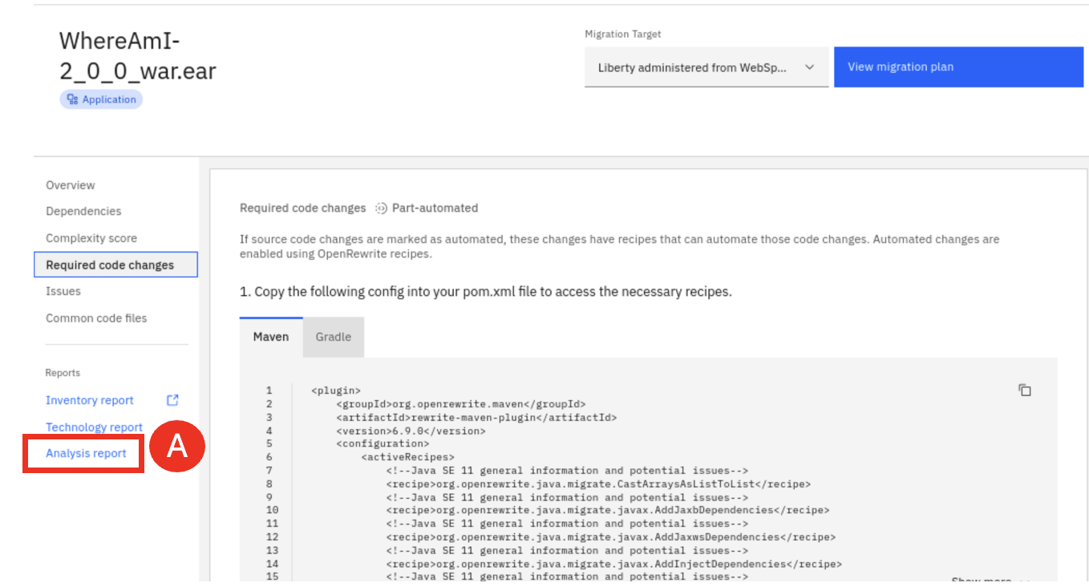

The Analysis report shows potential issues, their severity and possible solutions.

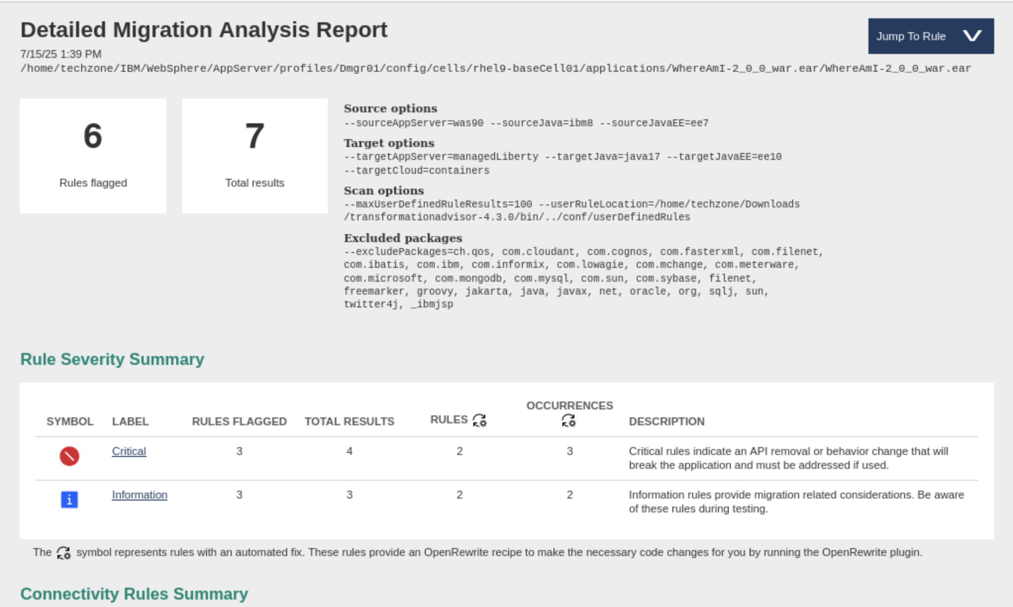

* 1. Click **View migration plan (A)**.

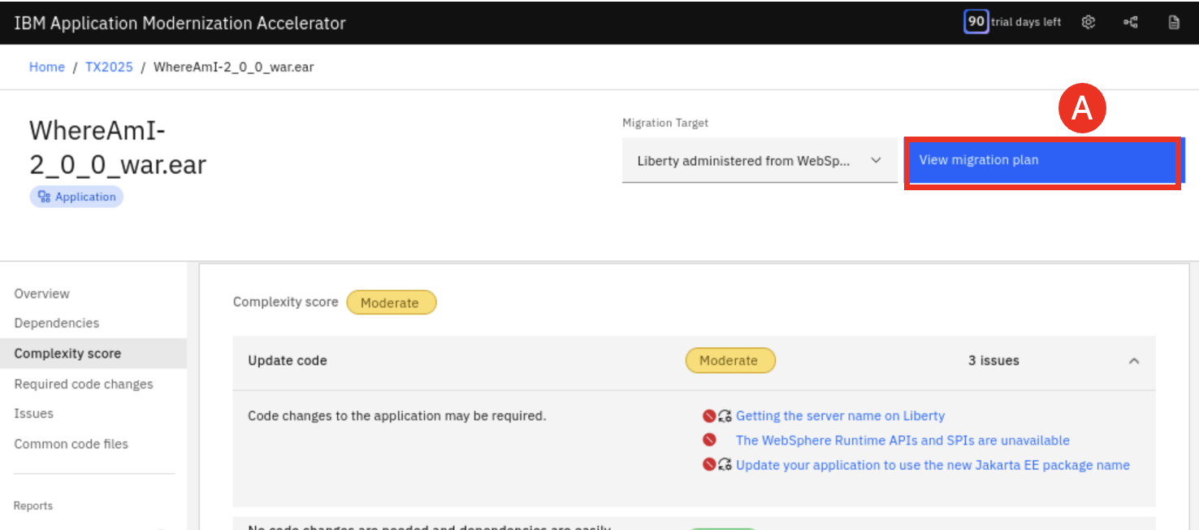

* 1. Click **Download (A)** to generate and download the migration plan so that you can re-use it in AMA Dev Tools.

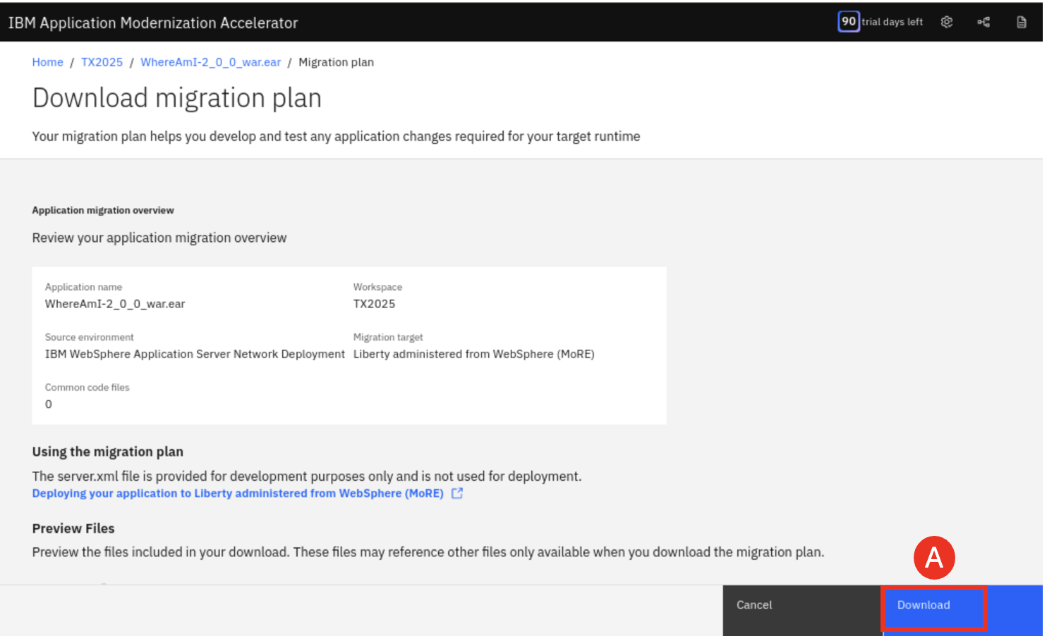

The AMA Migration Plan is now downloaded to the **Downloads** directory.

1. Use the AMA Dev Tools to apply fixes.
   1. In a terminal window, switch to the **WhereAmI** version 2.0.0 directory and open VS Code with commands:

cd /home/techzone/demos/AMA/WhereAmI-2.0.0-Project/WhereAmI

code .

* 1. In VS Code page, if you see the following Authentication required window, enter the password as: **IBMDemo0s!** and click **Unlock (A)**.

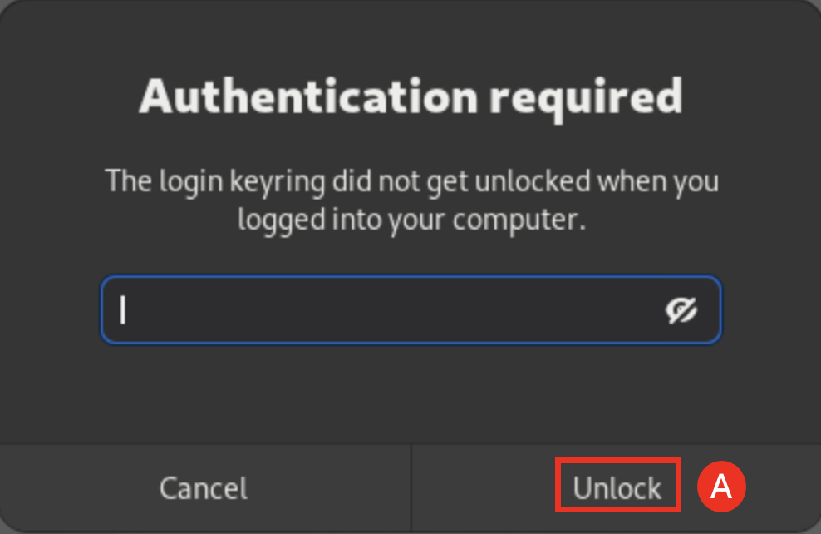

If a pop-up asks if you trust the authors of the files, click on “**Yes, I trust the authors**”.

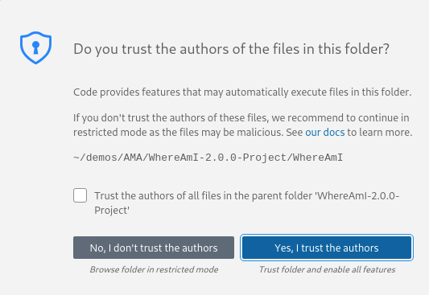

The VS Code editor window is displayed.

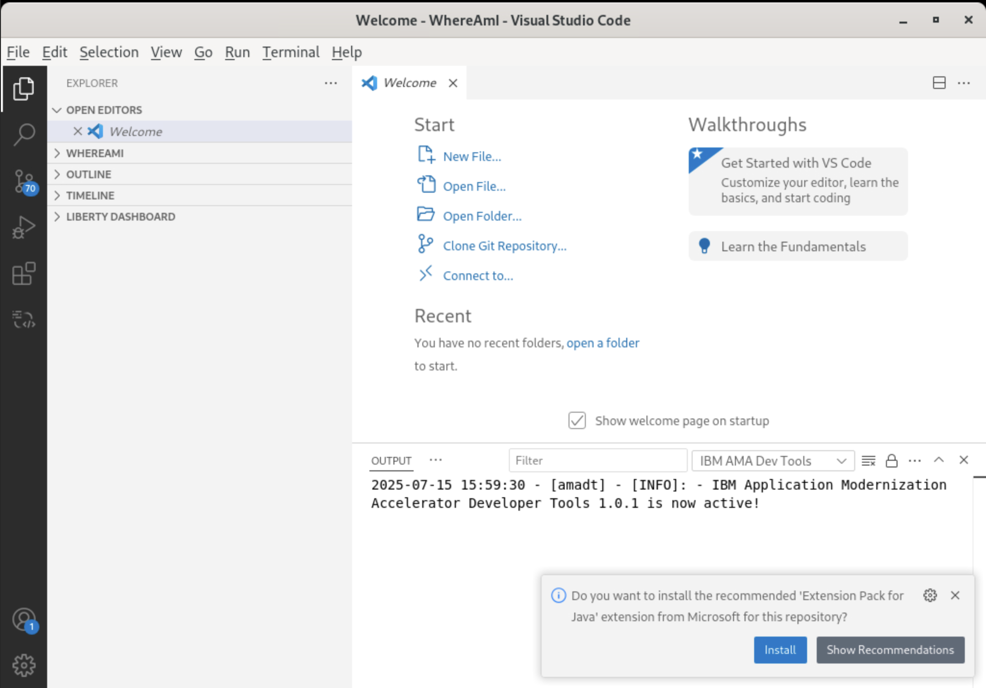

* 1. Cancel any **Install or update windows (A)**.

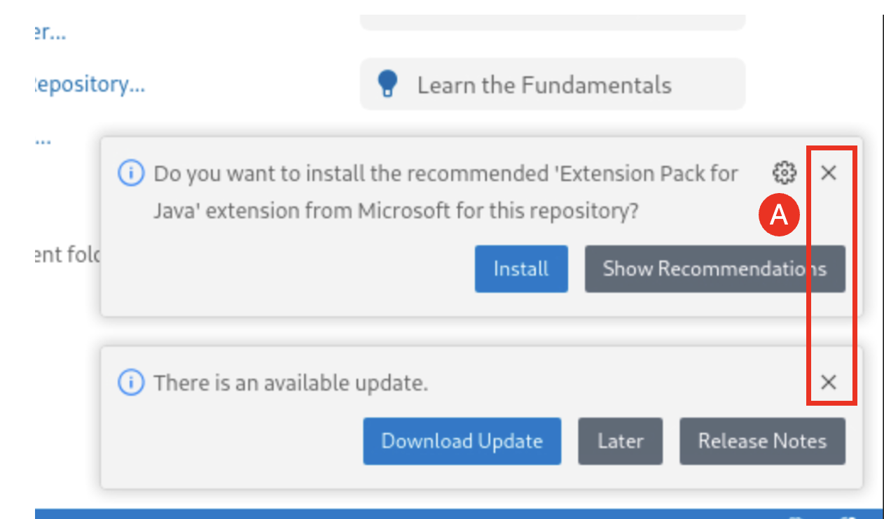

* 1. Edit **WhereAmI** application **pom.xml** and change the application version from **2.0.0** to **2.0.1** by clicking **WHERAMI (A)**->**pom.xml (B)** and changing the version value to **2.0.1 (C)**.

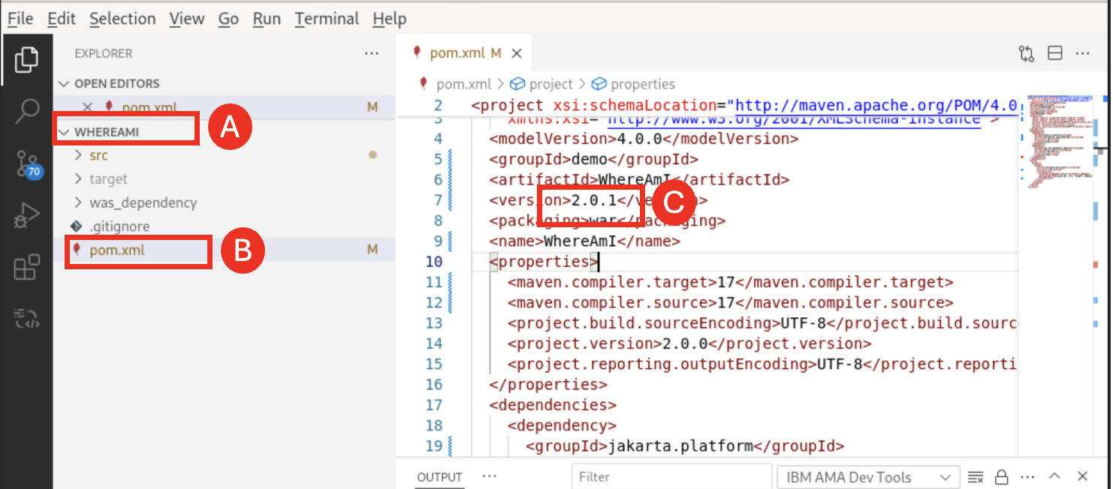

* 1. Save the change of **pom.xml** by pressing **Ctrl+S**, then close the pom.xml file.
  2. Right-click **src(A)** under **WHEREAMI** and select **Modernize Java Applications -> Modernize to Liberty (B)**.

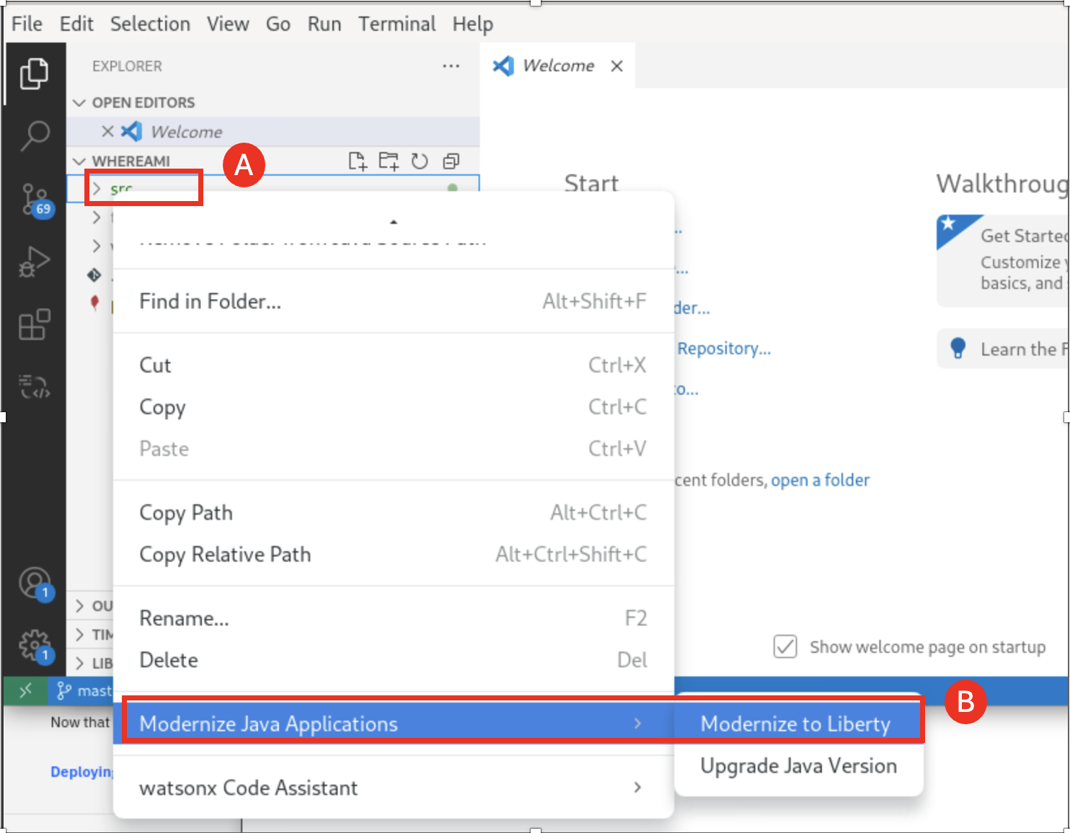

* 1. Next click **Upload migration plan (A)** to upload the AMA generated migration plan into AMA Dev Tools.

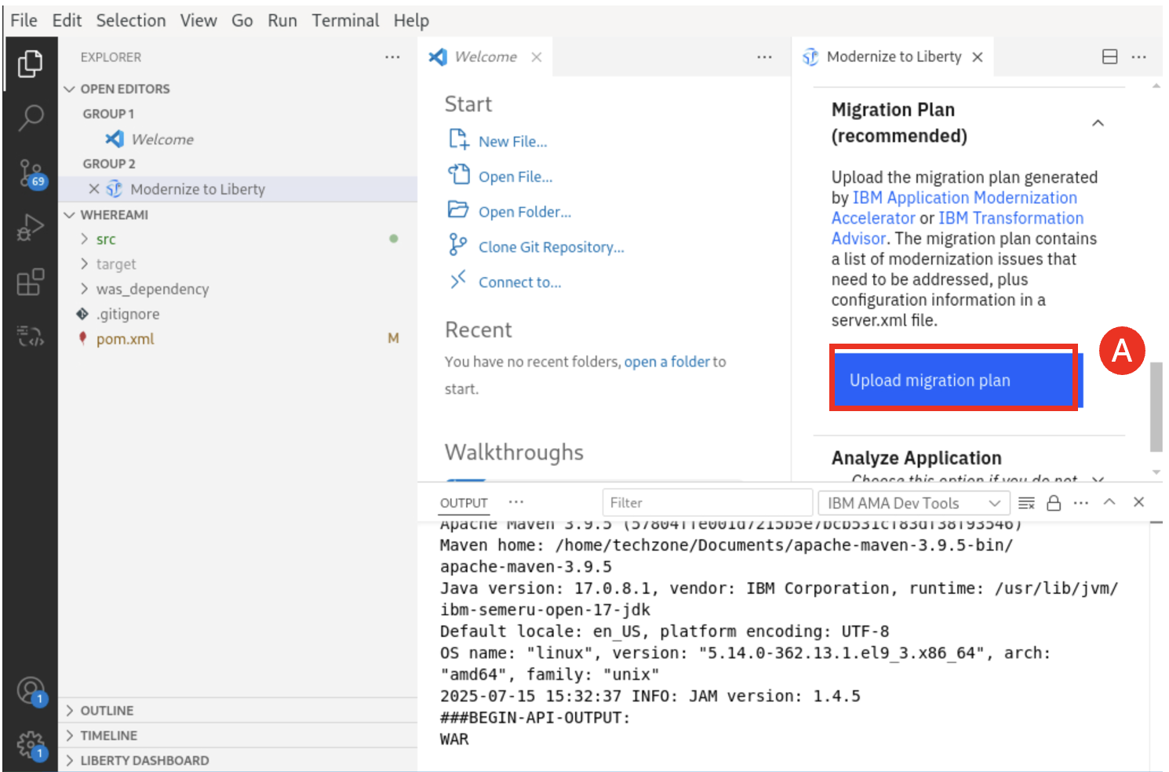

* 1. Navigate to the **/home/techzone/Downloads** directory, select the **AMA Migration Plan file (A)** and click **Open (B)**.

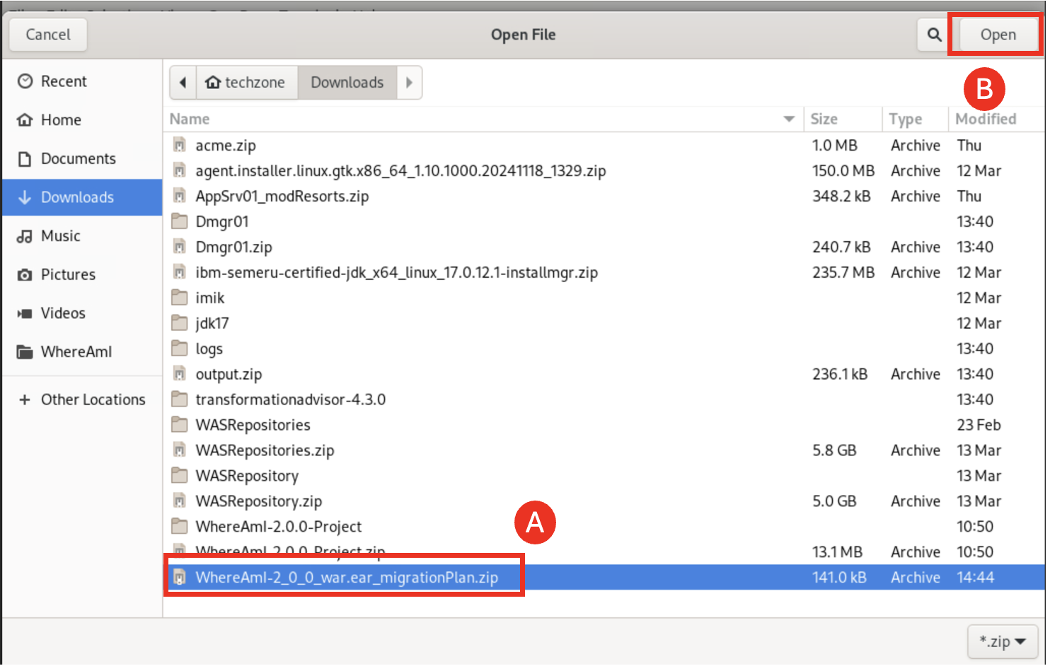

* 1. Make sure that the **box next to server.xml is checked (A)** and click **Proceed (B)**.

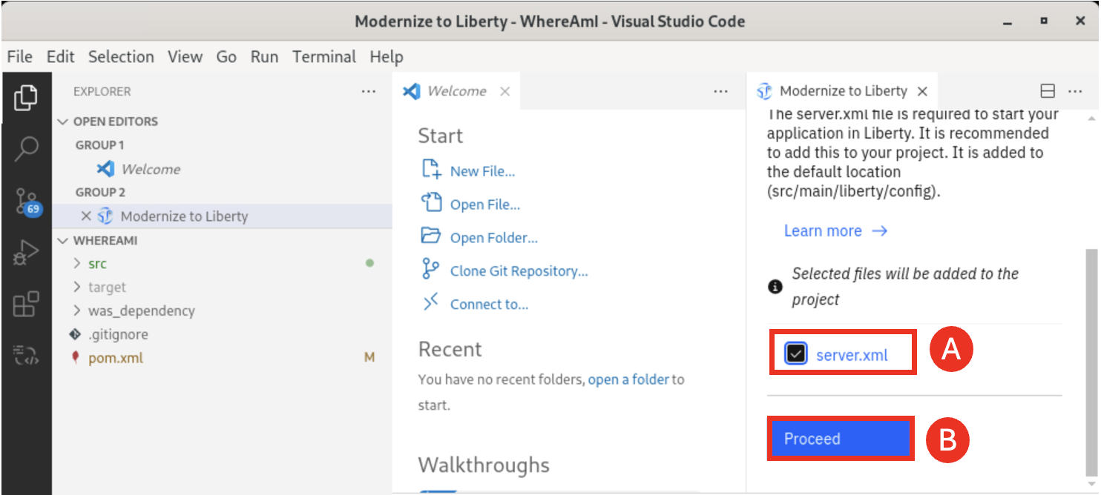

* 1. Review the identified modernization issues of the application, which are going to be automated fixes by AMA Dev Tools, and click **Run automated fixes (A)**.

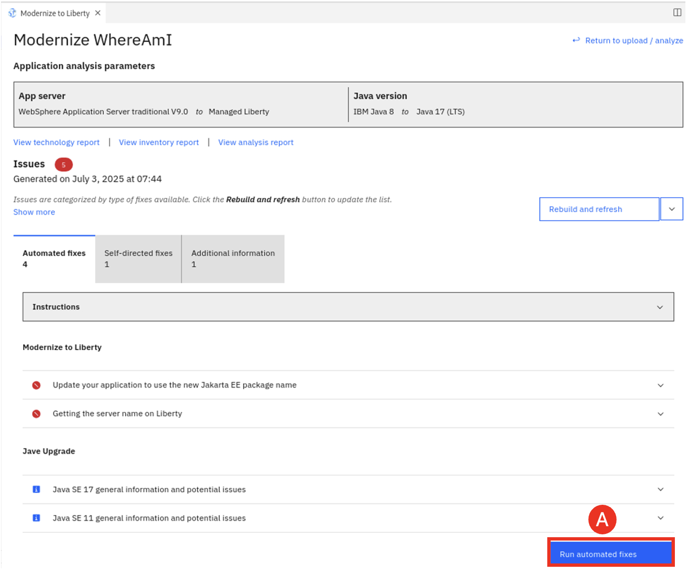

* 1. Click **Rebuild and refresh (A)**.

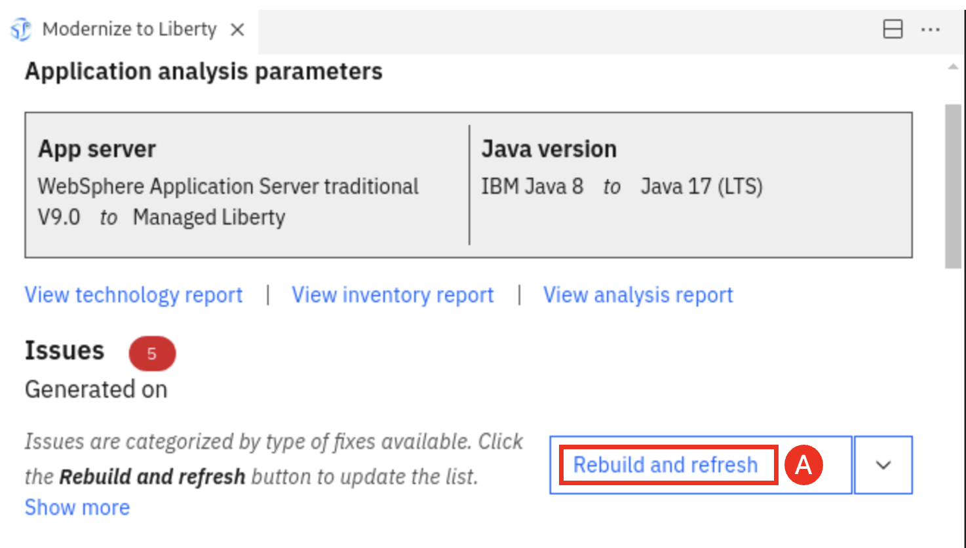

You can see that all issues have been resolved.

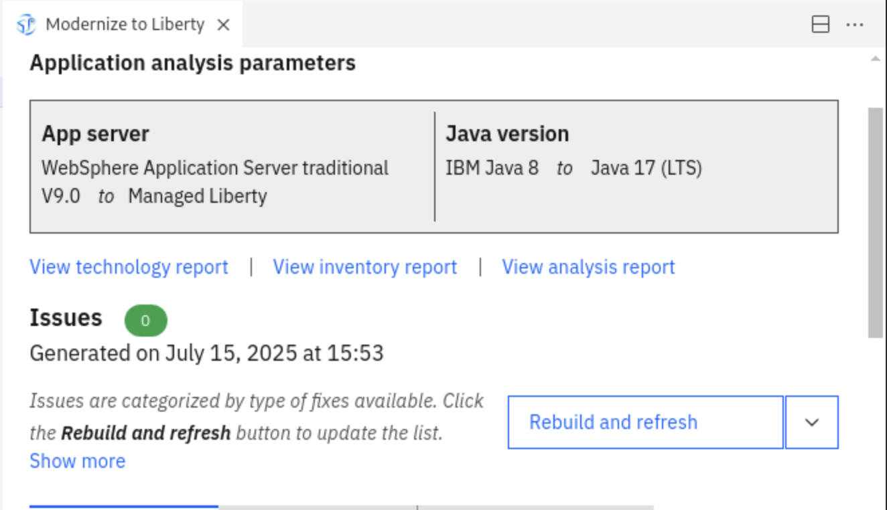

As a result, AMA Dev Tools creates a new version **WhereAmI** (2.0.1) of the application in the **target** directory.

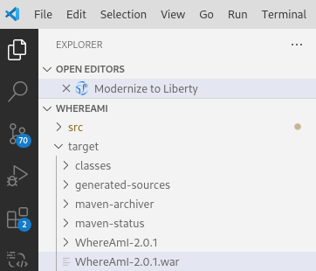

Now the new version of **WhereAmI** application is ready to be deployed to the **MoRE** environment.

1. Stop WebSphere servers.
   1. Now you have completed all AMA lab tasks, you need stop the WebSphere Deployment Manager, WebSphere ND Node Agents and IBM HTTP Server (IHS) by issuing the commands below:

cd /home/techzone/demos/ManagedLiberty-MoRE/tx-more-lab/scripts

./stop-was-servers.sh

**Summary**

In this lab, you learned how to evaluate the existing Java application using IBM Application Modernization Accelerator (AMA) and migrate it to the new Java runtime environment (in this case MoRE).

The intention of this application modernization exercise is to move an old Java application, **WhereAmI,** from traditional WebSphere V905 environment to IBM Modernized Runtime Extension for Java (MoRE) environment with minimal code changes.

AMA was used to analyze the application for compatibility with traditional WebSphere and determined that code changes can be made part-automated to speed up the modernization process. AMA Dev Tools with VS Code was used to modify the application code and to migrate it to the Java runtime environment.

The lab demonstrates that IBM AMA can help to accelerate the application modernization process, minimize errors and risks and reduce time to market.

